Published September 2015
IT Showcase Productivity Guide

Skype for Business for iOS
Customization note: This document contains guidance and/or step-by-step installation instructions that can be reused, customized, or deleted entirely if they do not apply to your organization’s environment or installation scenarios. The text marked by yellow highlighting indicates either customization guidance or organization-specific variables. All of the highlighted text in this document should either be deleted or replaced before distribution.
Skype for Business for iOS is a productivity app that brings Skype Meetings, presence, instant messaging (IM), voice, and video capabilities to your iOS mobile device. It has a new look and feel, at-a-glance view of your upcoming meetings and conversation history, simplified call controls, and other improvements.
To get Skype for Business for iOS, you need an iOS device running OS 8.0 or later. If you do not have the Lync 2013 mobile app installed on your iOS device, you can download the new Skype for Business app in the App Store. If you have an iOS device running iOS 8.0 or later and currently have the Lync 2013 mobile app, the new Skype for Business app will replace your existing app automatically. (Users of the Lync 2013 app for iPad will not receive an update. Please download the new universal (iPhone+iPad) version of the app from the App Store.)
Topics in this guide include:
Signing into Skype for Business for the first time
Joining meetings

Updating availability status

Managing contacts

Having conversations

For more information

Signing into Skype for Business for the first time
Before you start Skype for Business, make sure your device is connected to the Internet through either your cellular data plan or a Wi-Fi network.
- Tap the Skype for Business icon to open the app.
- Enter your sign-in address (e.g., alias@microsoft.com) and password, and then tap Sign In.
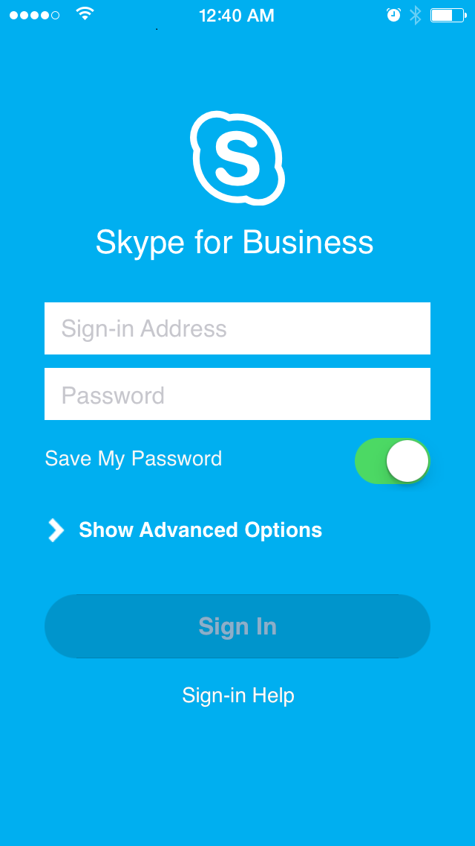
- Enter your mobile number with country and region codes (this should pre-populate any call-forwarding or simultaneous ring settings that are set up in Skype for Business for the desktop). If you are an Enterprise Voice customer and Skype for Business can't use a Wi-Fi or cellular data network to make an audio or video call, you will be called at this number and connected to the audio portion of the call.
- Tap Done.
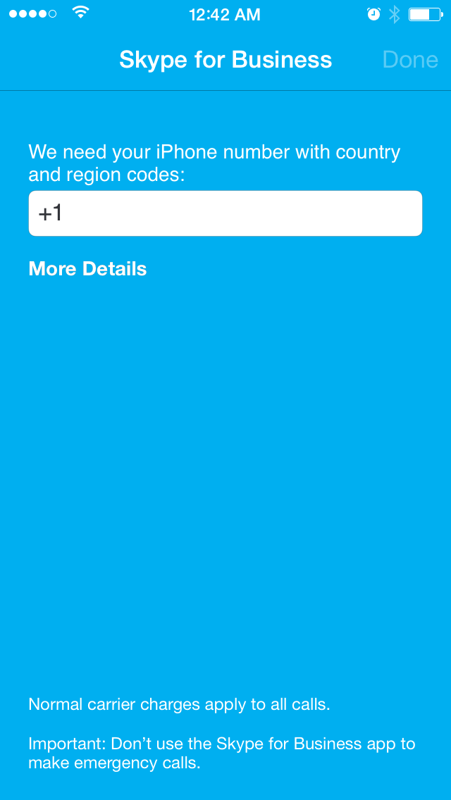

Joining meetings
There are several ways to join a Skype Meeting using Skype for Business for iOS. Once you join, you should be able to hear the meeting audio, see video of other participants, and view meeting content that is being shared. The default settings allow videos and presented content only when you have a Wi-Fi connection.
NOTE: You can also join a Skype Meeting without signing into Skype for Business or even having a Skype for Business account by using the link or toll-free number that was included in the meeting invitation.

Join a Skype Meeting
- On the main screen, under Upcoming meetings, tap the meeting you want to join. You can also view a list of upcoming meetings by tapping Meetings at the top of the screen.
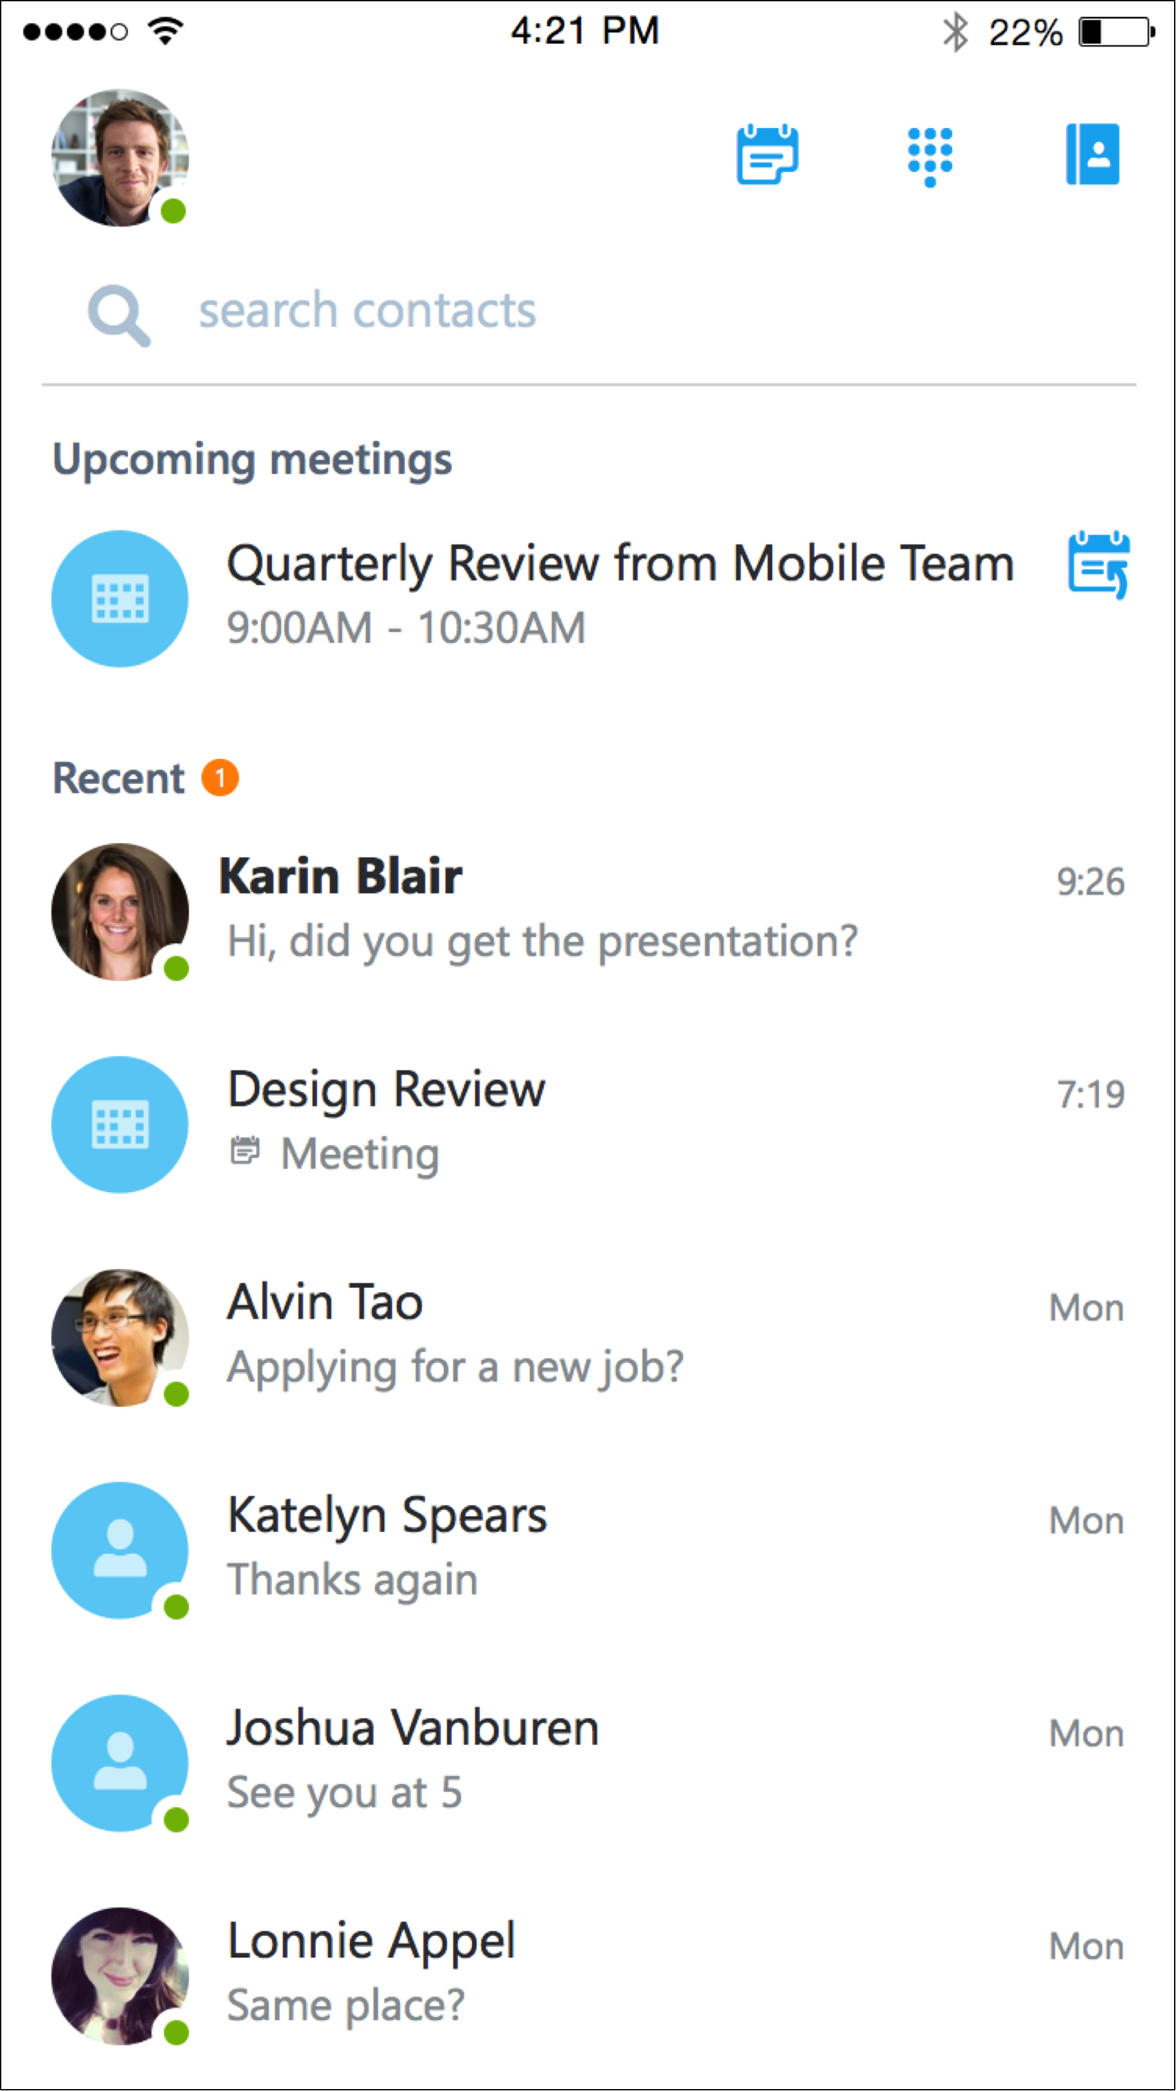

- On the Meetings information screen, tap Join meeting now.
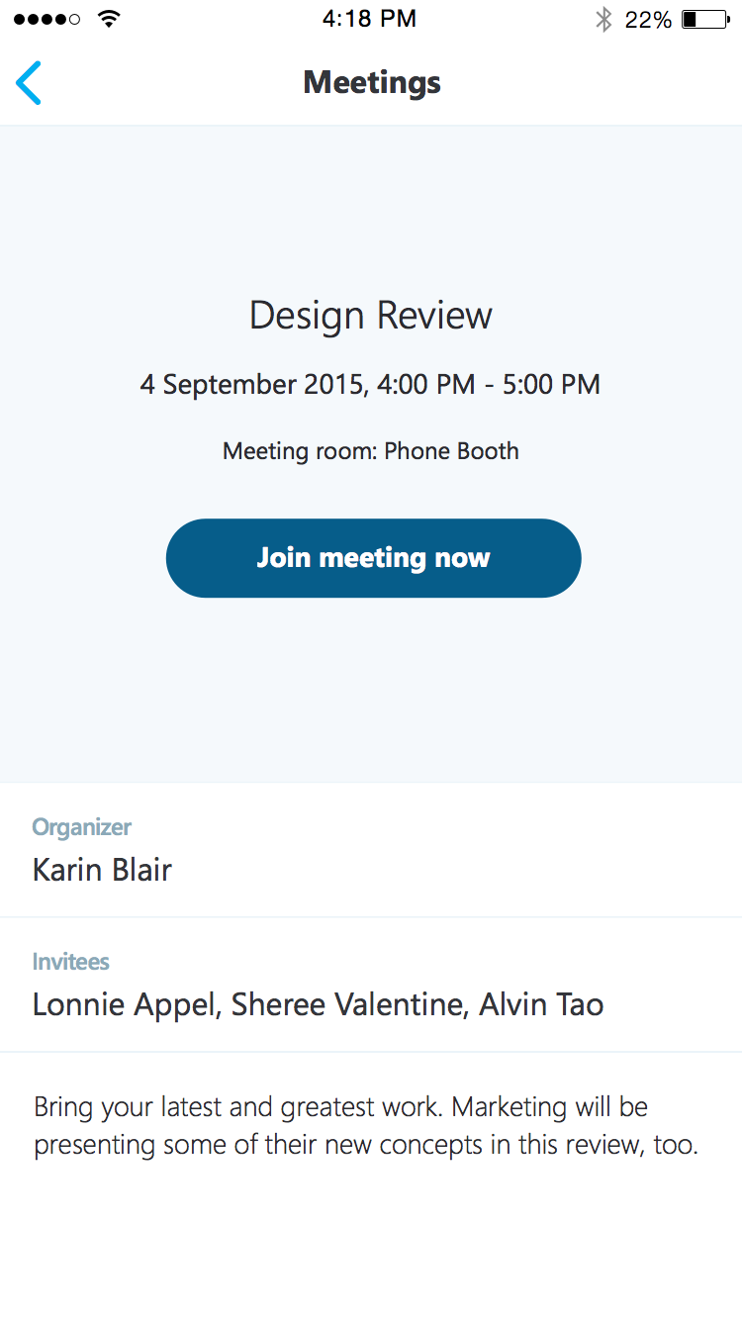

NOTE: Meetings can also be joined by using Quick Joinnext to a listed meeting. The Quick Join icon is not currently available on iPad.
Depending on how you set your VoIP call options, one of the following happens:
- You will be connected to audio or video using VoIP either by using Wi-Fi (if you are connected to a Wi-Fi network), or your cellular data plan. Regular data usage charges will apply.
- Or, Skype for Business calls you on your device and you will accept the Skype for Business call to join the meeting. This happens only when the voice and video call options (on the Skype for Business Options page) are set to ON and your device isn’t connected to a Wi-Fi network.

Waiting in the meeting lobby
The meeting lobby is an online waiting area. The meeting leader can control access to the meeting or admit someone who doesn’t have the correct meeting credentials. If the meeting leader has enabled the meeting lobby, you will need to wait until the meeting leader admits you to the meeting.
NOTE: While you are waiting in the meeting lobby, don’t move to another app. Your request to join the meeting will be cancelled if you leave.

What you can do in a Skype Meeting
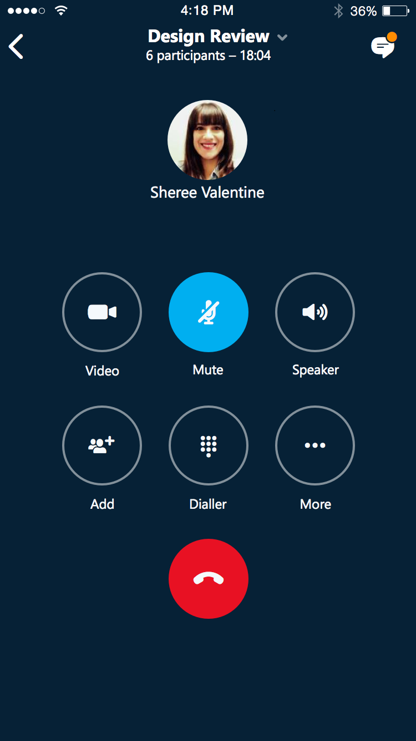
- Use Video to start your camera.
- Use Mute to mute and unmute your microphone.
- Use Speaker to turn the device’s speaker on and off.
- Use Add to add new participants to the meeting.
- Use Dialer to call someone to join the meeting.
- Use More to access additional features.
NOTE: These additional features are currently in development and will be available in the next release.
- Use End call to leave the meeting or end the conversation.
- Tap Text in the upper right of the screen to type a message or read other participant’s messages.

Answering a call during a meeting
If a call comes in during a meeting, you will see an incoming Skype for Business call screen.
- Tap Answer to put the meeting on hold and answer the call
- Tap End call to ignore the incoming call and remain in your meeting.

Switch between a call and your meeting
- Use the back arrow in the upper left of the call screen to return to the main screen. The meeting that is on hold will be listed under Recent.
- Tap to select the meeting that is on hold to view its call screen.
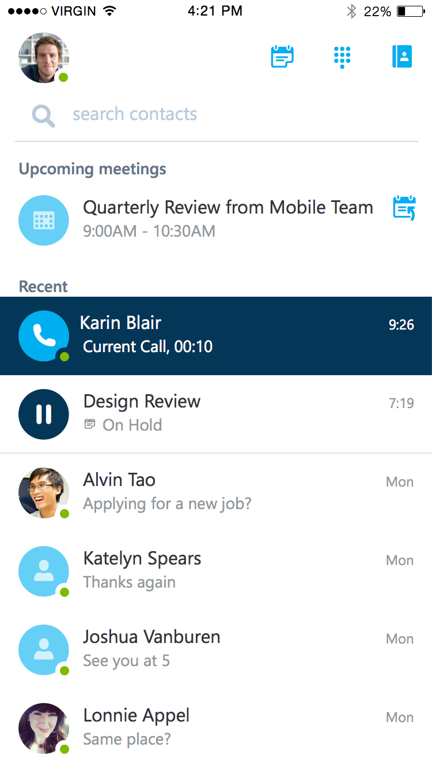

- You will remain on your active call until you resume the meeting by tapping Call on hold on the meeting call screen.
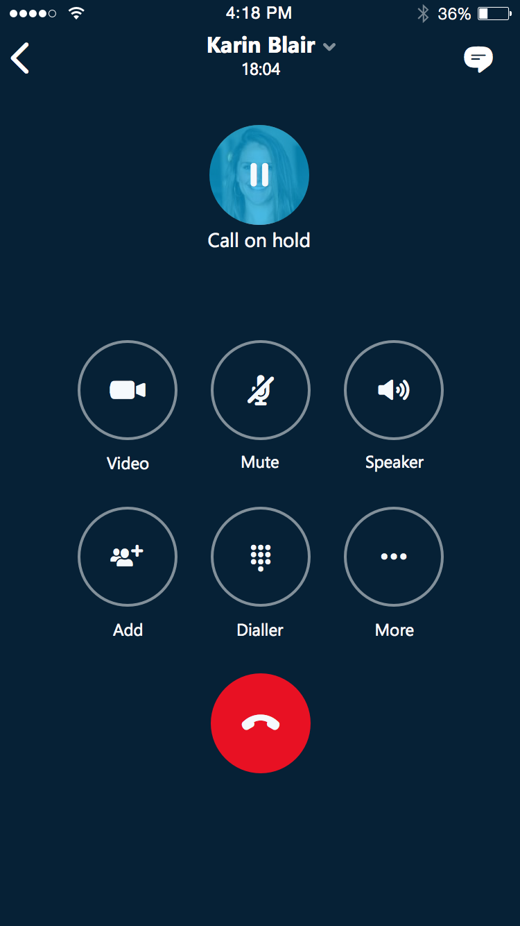

Updating availability status
Your presence information includes availability status such as Available or Away and is represented by a color-coded green, yellow, or red presence indicator. When you use Skype for Business on your mobile device, it will let people who view your contact information know that you are using a mobile device.

Setting your status
- To change your status, tap your photo with statuslocated in the upper right corner of the main screen.
- Tap the Status arrow.
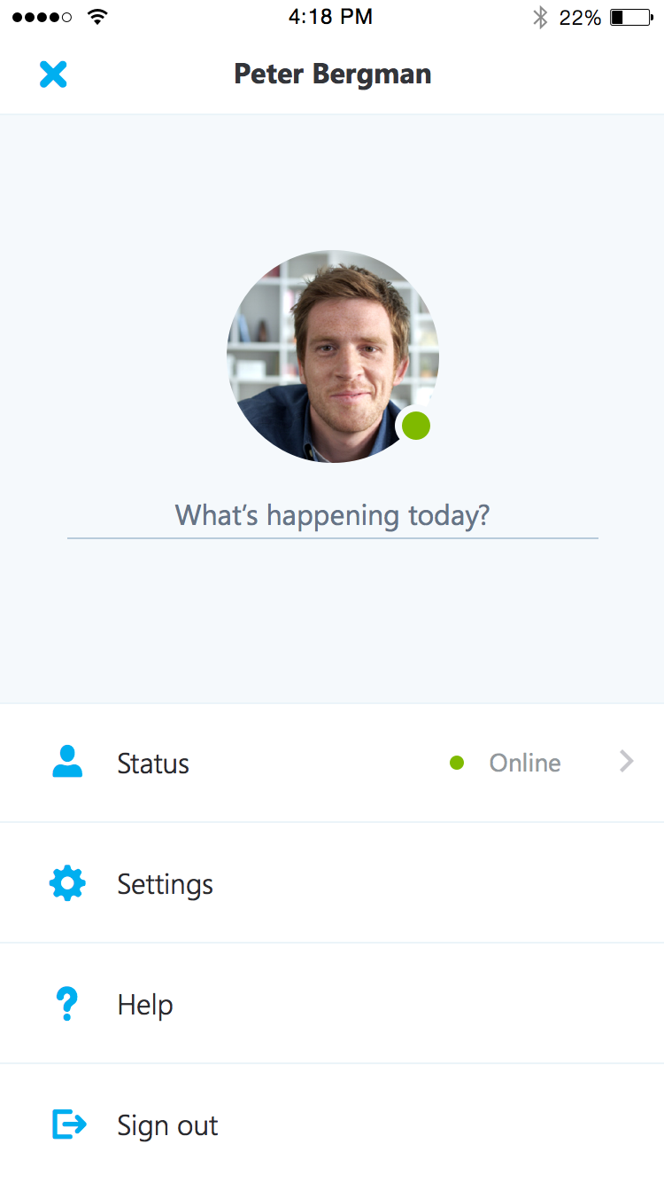

- Select your status from the availability status list.
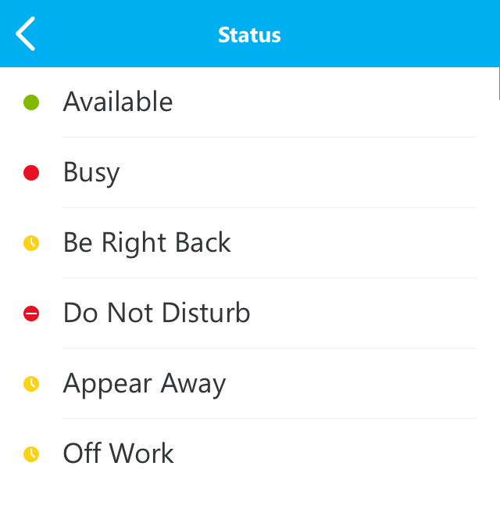

Setting status automatically
When you sign in, you remain signed in as long as there is connectivity. If you are in a meeting or on a call, your status updates automatically. If you are not actively using the app on your mobile device or Skype for Business on your computer, your status appears as Inactive. If you have connectivity but haven’t used the app for 10 days, you will be automatically signed out.

Setting a personal note
- Tap your photo with status in the upper right corner.
- Tap What’s happening today?
- In the note area, type any note you want. ‘
- The note appears with your contact card.
NOTE: When you change Automatic Replies (out of office) settings in Microsoft Outlook, it automatically appears in the personal note area in Skype for Business. This note stays in Skype for Business until you cancel the note in Outlook or type a new note

Managing contacts

Find a contact
From the main screen, tap search contacts then start typing a name, phone number, direct extension, or email address in the search box.
The list of contacts will start to display as soon as you begin typing, and the results will be refined as you continue to type the name you are searching for.
NOTE: If Contacts are ON, when you search for a contact, the search results will include contacts that are on your device. To limit results to the Global Address List (GAL), you can go to your device’s Settings, select Skype for Business from the apps list, and use the slider bar to turn access to your device’s local contacts OFF.
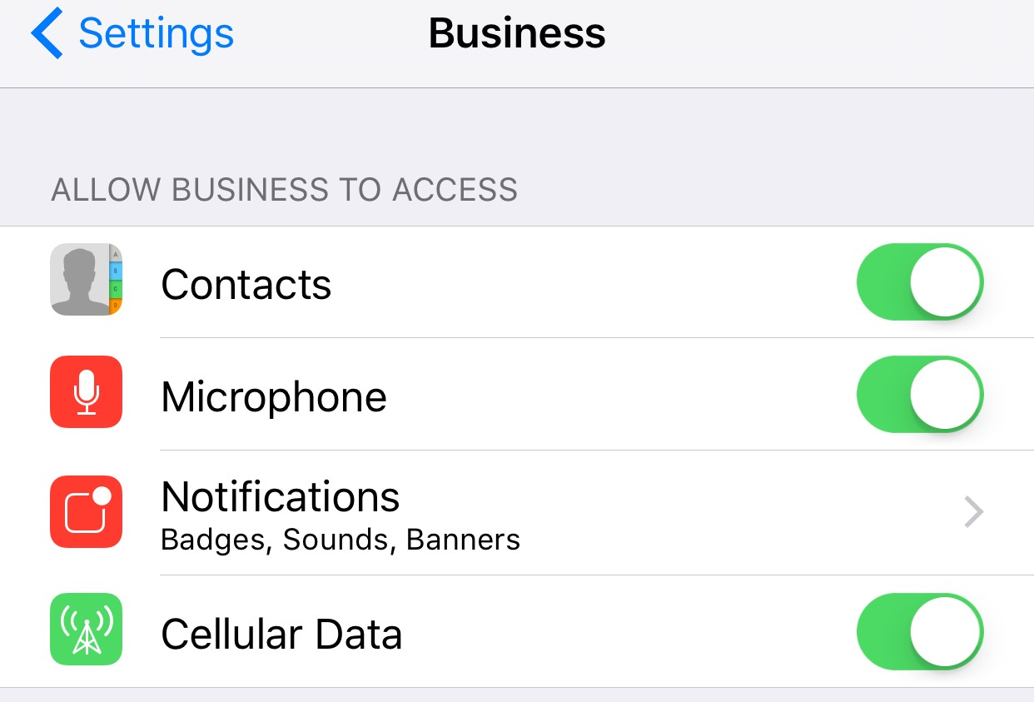

View and edit your Contacts
To view your Contacts list, go to the Contacts screen, and then tap any of the groups to expand it. The Contacts list in Skype for Business on the desktop is the same as the one in the Skype for Business app. You can now add/remove contacts from the Contacts list in the mobile app.

View someone’s profile
The profile displays status, personal notes, and office locations for people, and provides several ways to communicate with them. For example, you can send an instant message (IM), start an audio or video call, or send an email message directly from someone’s profile. To view a contact’s profile:
- Find the contact in your Contacts list, or start typing a person’s name in the search box.
- Tap the contact’s name.
- At the top of the conversation screen, tap the down arrow next to contact’s name.

- Tap profile to open the contact’s profile screen.
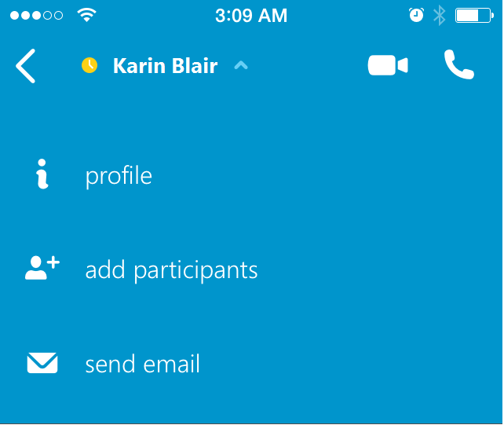

Having conversations

Start a conversation
From Skype for Business, you can start a chat (IM), a voice call, or a video call with a single tap on a contact’s name.
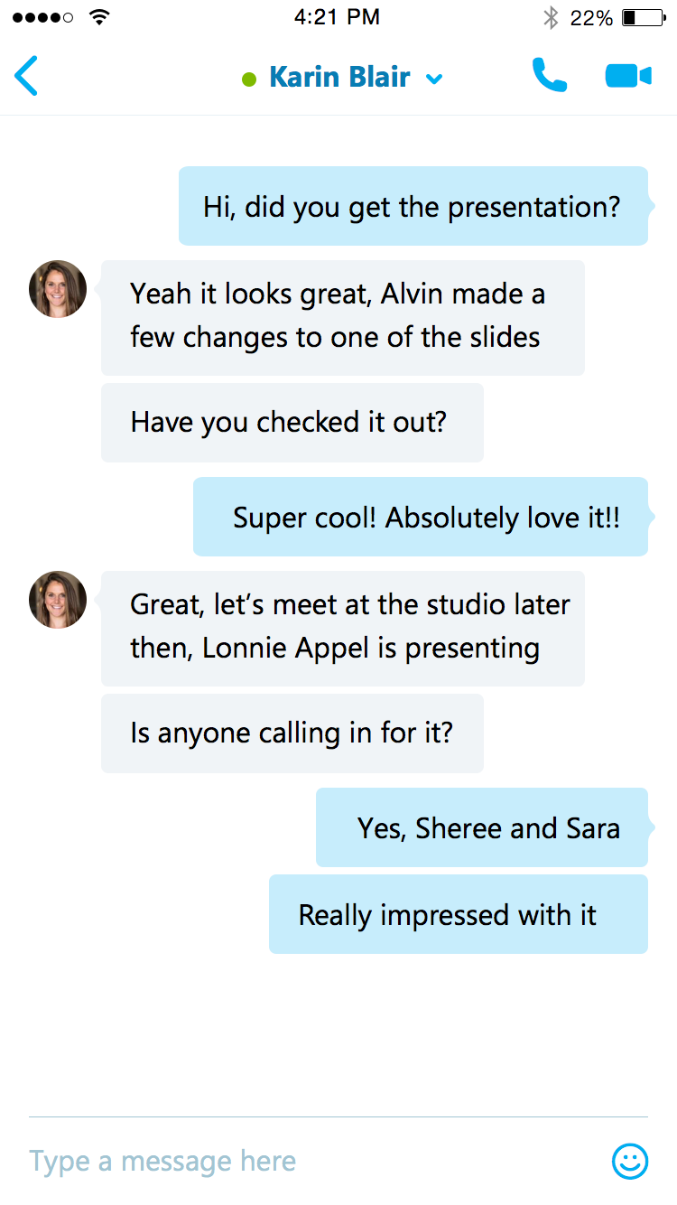

To start conversations:
- Type a message, and tap Send .
- Start a video chat by tapping Video .
- Make an audio call by tapping Call .

Joining a conversation
IM. When someone sends you an instant message and you are in Skype for Business, a notification appears at the top of the screen. To accept the invitation, tap the notification. If you receive, an instant message while your device is locked or when Skype for Business is running in the background, a notification appears indicating that you have a new instant message. To accept the invitation, tap the notification. To ignore the invitation, just let the notification time out.
Audio. When you get a Skype for Business call, it looks the same as any other call you get on your iOS device. The only difference is that when you get the call, the ringtone will be the default Skype for Business ringtone (this ringtone cannot be changed), and the incoming call screen will have a Skype for Business logo on the left.
Video. When you receive a Skype for Business video call:
- Tap Video to accept an incoming audio and video call
- Tap Audio to accept an audio-only call.

Find recent or missed conversations
Missed and recent conversations are listed on the main screen under the Recent heading. Tap a listed conversation to open it.
Customization note: Synchronizing Conversation History between mobile devices and Microsoft Outlook may or may not be available depending on how IT Administrators have configured the environment. If your implementation does not synchronize between Outlook and Skype for Business for iOS, you may want to customize the following note to include in this section. Please remember to remove the highlighting.
NOTE: The conversation history in your Recent list only includes the conversations that you initiated or participated in while using your mobile device. To view the list of conversations that were initiated from or participated in from your computer, view the Conversation History folder in Microsoft Outlook.

Delete a conversation
To delete a conversation from the Recent screen, swipe the conversation you want to delete and tap the garbage can.
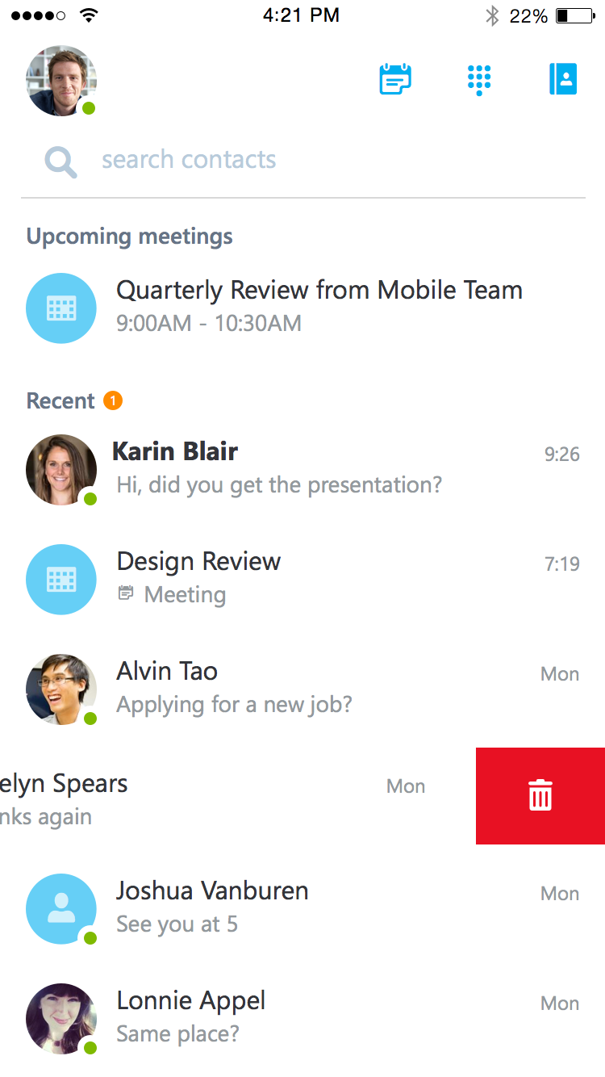

For more information

For more great productivity guidance, visit…
http://microsoft.com/ITShowcase/Productivity

Microsoft IT Showcase
http://www.microsoft.com/ITShowcase

Skype for Business is coming to iOS
https://support.office.com/article/1a2cf653-955b-4329-b289-db7a67d32bfd

Download, install, and sign in to Skype for Business for iOS devices
https://support.office.com/article/3239c8a3-cf55-4ff0-a967-5de51911c049

Need help signing in to Skype for Business (iOS)?
https://support.office.com/article/aa89f3d2-44e7-4d8a-9a26-643fbf5c732b
For more information about Microsoft products or services, call the Microsoft Sales Information Center at (800) 426-9400. In Canada, call the Microsoft Canada Order Centre at (800) 933-4750. Outside the 50 United States and Canada, please contact your local Microsoft subsidiary. To access information via the web, go to:
http://www.microsoft.com
© 2015 Microsoft Corporation. All rights reserved. Microsoft and Windows are either registered trademarks or trademarks of Microsoft Corporation in the United States and/or other countries. The names of actual companies and products mentioned herein may be the trademarks of their respective owners. This document is for informational purposes only. MICROSOFT MAKES NO WARRANTIES, EXPRESS OR IMPLIED, IN THIS SUMMARY.

