How Microsoft IT planned and deployed Skype for Business to the
Office 365 Enterprise E5 cloud

Contents

Using the cloud for unified communications 1
New Skype for Business services 1
Improving service quality 2
Planning a Skype for Business migration to the cloud 3
Prioritizing drivers to the cloud 3
Overcoming complexities and challenges 4
Two-step option: Planning for hybrid versus cloud-only 4
Identifying unique environmental and market characteristics 6
Deploying Skype for Business in the cloud 7
Choosing the order of user migrations 7
Maintaining productivity throughout deployment 8
Moving users to the cloud 10
Addressing technical challenges 11
Transitioning from SIP trunking to cloud-based PBX 12
Accounting for inherent service limitations 13
Getting to a multinational cloud 14
Developing tools and promoting communications 15
Monitoring service health and focusing on quality 15
Refining and optimizing call quality management tools 16
Results, benefits, and best practices 19
Cost savings 19
Benefits of the migration experience 20
Best practices for successful Skype for Business cloud migration 21
For more information 22
Microsoft IT Showcase 22

Using the cloud for unified communications
Businesses everywhere and of all sizes are moving to cloud-based IT services to save money, improve customer satisfaction, stay competitive, and accelerate time-to-market for their products. Although cloud computing is still a new IT model for many companies, the word is getting out that shifting to the cloud offers advantages and capabilities that were previously out of reach. Many IT professionals are eager to find out how they can use the cloud to their advantage.
However, simply talking about the cloud and actually making cloud services an integral part of your IT strategy are two different things. Nearly everything we touch, use, or manage in a modern work environment—apps, devices, data, even networks and storage—could be optimized by using or managing it in the cloud. This potential can be overwhelming, and even the most astute IT professional might struggle to see the first steps toward integrating cloud services into critical business workloads.
One such workload is unified communications, the technology that connects people using telephony (voice) services, online conferencing, and related technologies such as presence, content sharing, and instant messaging (IM). Skype for Business has been a leader in this space for many years, and along with the other enterprise services that have made their way to the cloud, Skype for Business offers a cloud-based option for hosting the private branch exchange (PBX) and teleconferencing software that unified communications requires.
Because Office 365 Enterprise E5 supports a hybrid architecture, we could achieve cloud-based unified communications in a series of manageable steps. Hybrid architecture works around the need to take all services directly to the cloud—a need that is unrealistic for many businesses. With hybrid, we kept some users on-premises, moved others to the cloud for specific services only, and then moved those users to a fully cloud-based solution.
Migrating users to Skype for Business in the cloud has saved us $124,000 per day so far. The business case study How cloud-based PBX and PSTN save Microsoft IT more than $120,000 per day with Skype for Business offers more details about the business justification and measurable outcomes.
The Office 365 Enterprise E5 hybrid architecture was crucial for getting our Skype for Business cloud migration successfully off the ground. It also enabled us to establish regional deployments in parts of the world beyond North America, in support of our vision of a multinational cloud that connects Microsoft workers and offices globally.

New Skype for Business services
Microsoft IT manages unified communications (and other services) around the world—more than 114,000 employees and 82,000 partners, vendors, and contingent staff at more than 775 locations. Microsoft IT also manages around 18,000 meeting room and common area accounts. We deploy Skype for Business to every new employee and we use Skype for Business at every business touchpoint. Microsoft is using new and advanced Office 365 Enterprise E5 Skype for Business telephony capabilities and realizing tremendous value, including:

Cloud PBX
Cloud PBX is a modern, cloud-based voice infrastructure that supports standard telephony functionality. PBX systems manage calls inside of your company, for example, by routing calls to extensions, direct lines, or an attendant. In the past, PBX systems were on-premises, managed by a third party, and required significant hardware investment. Cloud PBX—cloud-based call management—delivers familiar business phone call control and management features, such as call waiting, directly from Office 365.
With Skype Cloud PBX, we no longer have to contract with a traditional carrier for service, use traditional phone hardware, or use an on-premises PBX. Calls are routed over the Internet. Cloud PBX hardware support and management usually happens at an IT datacenter, rather than at a dedicated PBX site. We can even replace expensive, proprietary desk telephones with lower cost headsets.

PSTN calling
Public switched telephone network (PSTN) calling is the ability to make and receive phone calls through the Cloud PBX infrastructure. Combining Cloud PBX with the PSTN calling service creates a complete enterprise telephony experience, with Microsoft as the provider. A fast, flexible provisioning environment is supported by Office 365 and the Microsoft global network.
The PSTN calling service connects private exchanges to the PSTN. In a typical scenario, a caller uses a land line or a cell phone in situations where Voice over IP (VoIP) is challenging. PSTN calling routes external calls to a traditional telephone number, such as a person, or to a different organization that has its own PBX. With the combination of Cloud PBX and PSTN calling, operations are optimized and, in many cases, tasks are completely automated by Office 365.
Consider the impact on corporate moves or new-hire scenarios. In the past, telecom managers had to program PBXs to assign users to specific phones. Today, phone numbers and presence information are automatically associated with a user account through Office 365. The information follows that user to any location, computer, or mobile device. Today, moving to a different office can be as simple as picking up your laptop and connecting to the network.

PSTN conferencing
PSTN conferencing is a simplified meeting process that supports conferencing using traditional phone dialing, and includes the ability for users to have the meeting call their phone. PSTN conferencing includes both dial-in and dial-out functions.
Dial-in PSTN conferencing simplifies the meeting process. It lets us add telephone access—also referred to as an audio bridge—to meeting invitations. Using this feature, attendees can join a meeting from any telephone with a local or toll-free number. This feature is useful when attendees can’t connect to the Internet, don't have a stable Internet connection, or don’t have audio access from their PC, tablet, or laptop.
Dial-out PSTN conferencing lets online meeting attendees add others to a meeting by dialing their phone number. This feature offers the flexibility of easily adding someone to a conference simply by calling their phone.
Using PSTN conferencing services—built directly into Skype for Business—means that we don't have to outsource conferencing to third parties.

Improving service quality
Our vision for achieving optimal service quality for Microsoft solutions is driven by user experience and customer advocacy.

User experience
We are determined to offer the best user experience for our employees, contractors, and partners who are part of the Microsoft workforce. We do this by designing and using solutions that meet varied and ever-changing expectations, including the ability to be productive in new ways from anywhere, on any device.

Customer advocacy
Microsoft IT often uses new products and services before anyone else, serving as the company’s “first and best” customer. We work with product teams to deploy new software and services, and our feedback affects product design and features. We help improve quality before products reach a larger audience. After products and services go out to more people, our employees serve as ambassadors for new products.
In March 2014, Microsoft launched the Get to Green program, in which IT partnered with the Skype for Business product group. Our goal was to make the end-to-end Skype for Business user experience the best in the industry, with green being the desired state of service as shown in our metrics.

To succeed, we had to upgrade hardware, address server and networking issues, and ensure a positive experience for users on unmanaged personal devices. We transitioned core Skype for Business components from on-premises to the cloud. To do this, we undertook a multi-year process of planning, learning, and execution that led to positive results, both for IT and for the businesses and users it serves. Get to Green comprises seven key pillars:
- Media quality and telemetry
- Client stability and performance
- Server and network stability
- Incident and change management
- Conference room health
- Communications
- Release management and early adoption
This white paper describes the approach we used to implement cloud-based unified communications at Microsoft, the actions we took to overcome various technical and business challenges, the results we achieved, and the lessons and best practices we saw along the way.

Planning a Skype for Business migration to the cloud
As any IT professional knows, when you embark on a new project, you must carefully weigh the variables, risks, priorities, and obstacles involved. When you face the “make vs. buy” decision about new IT investments, you're looking for a platform you can trust to support your users for the next 10 years or more. In rolling out a new unified communications solution for your organization, you want to understand all you can about the technology that drives voice and conferencing services, so you can anticipate technical challenges and overcome them with intelligent action.
When we first began upgrading Skype for Business at Microsoft, we looked for ways to be as intentional and realistic as possible to make the project succeed. We decided the best approach was to define our key problem areas and then identify opportunities to improve them, including:
- Upgrading server hardware and creating redundancy.
- Improving network performance, particularly wireless access in our buildings.
- Managing a wide variety of company- and user-owned devices.
- Educating users about best practices and devices to use with Skype for Business.
- Creating a user feedback loop, so we could quickly identify and correct issues.
Starting with the Get to Green program and continuing for about two years, we were successful in each of these areas. In June 2016, we reported on our progress in Improving service quality in Skype for Business. Since then, we’ve maintained the best practices we learned, while gradually starting to move our Skype for Business users to the cloud.

Prioritizing drivers to the cloud
We wanted to do a good job planning the migration and have a way to gauge our success afterward. This meant understanding our needs, anticipating the business and technical impacts of each step in the process, and assessing our priorities. In particular, we prioritized the key realities that prompted our move to cloud-based unified communications.
- Risks inherent in co-located services. Our on-premises Skype for Business implementation was in datacenters, on hardware that was shared with other enterprise applications. As a result, whenever a networking or infrastructure change occurred, there was a risk that the change could negatively affect Skype for Business. Moving to the cloud would give us the freedom to put Skype for Business into a multi-tenant environment where it could be managed and scaled autonomously, without dependency on other services in the environment.

- Dependencies on other systems. Similarly, Skype for Business has dependencies on other services. In particular, Skype for Business depends on Microsoft Exchange, which we had already started to migrate to the cloud. For Skype for Business to run successfully with cloud-based Exchange, it needed to be in the cloud, too.
- Discontinuous service management. Services in the cloud are easier to manage than on-premises services, due to the freedom that cloud-based architectures offers and the tools to help IT managers scale and optimize service levels. One of our key successes was the ability to manage the Skype for Business service end-to-end.
- Inconsistent quality monitoring. A significant limitation of our on-premises Skype for Business environment was the lack of visibility into network and user issues. By migrating to the cloud and situating the Skype for Business service as a tenant in a cloud-based system, we could expect better capabilities for detecting and remediating gaps in service quality.
- Capital and operational expenses. Running services in a datacenter is inherently costly. Servers must be housed, cooled, powered, updated, and fine-tuned to maintain optimal operations. The services that run on each server must be carefully monitored for maximum operability and efficiency. As with nearly every cloud migration, by transferring the burden of service operation from a shared datacenter environment to the cloud, we anticipated significant savings in our capital (hardware and infrastructure) and operating (IT management and disaster recovery) expenses.

Overcoming complexities and challenges
We needed to spell out our logistics concerns, so we could outline our approach. These questions ended up guiding our process:
- How do we break the migration into manageable tasks and phases?
- How do we choose which users get migrated first?
- What interdependencies among users might require coordination?
- What technical prerequisites impose potential limitations on the roll-out?
- How do we upgrade our infrastructure to support cloud-based Skype for Business traffic?
- Which business users need the upgraded technology most urgently, and which can wait?
- How do we maintain and improve stability of the Skype for Business service throughout the migration?
The last question was important because it spoke to our core IT mission to offer a positive user experience while we modernize and innovate. Like any IT department, we wanted the businesses we support to be efficient and productive while we made a substantial transformation in a key service that is used in all aspects of the business every day.

Two-step option: Planning for hybrid versus cloud-only
In an ideal world, you would simply turn off your on-premises workloads and immediately start running them in a cloud-based environment. Indeed, companies just getting started with unified communications have the luxury of going cloud-only, and never need to bother with migration. Most large companies—Microsoft included—that have had an on-premises unified communications system find it difficult, or even impossible, to migrate directly to a fully cloud-based solution. Instead, we took the journey in two steps: migrating to a hybrid solution, and then from there to being fully in the cloud.
The hybrid configuration at Microsoft consists of using the cloud for IM, presence, and conferencing, while keeping voice services on-premises using third-party carriers. The decision to migrate the other services before migrating voice was based mostly on the complexities of porting existing phone numbers from third-party carriers to our cloud-based system. Hybrid cloud is a temporary step for us, as it is for many large companies with old unified communications systems.

In the hybrid solution, users were given the cloud-based conferencing service, but kept traditional PBX services, as shown in Figure 1. The push to cloud-only focused on migrating users to the cloud-based voice services. By separating the task into two steps, we could control quality and continuity of service to all users as we worked on understanding the specific challenges of moving off the old PBX systems.
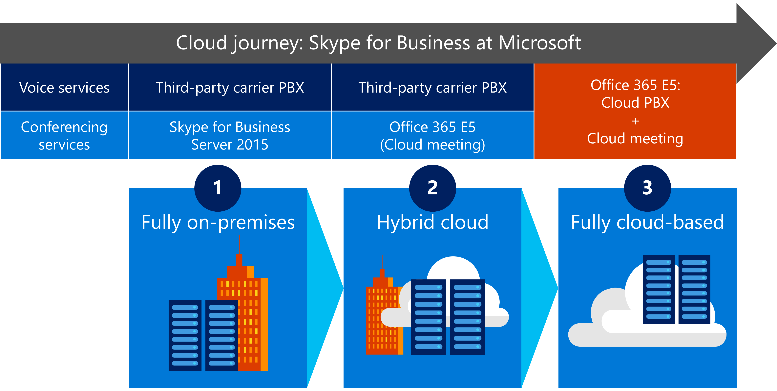
Figure 1. Three steps in our Skype for Business journey from on-premises to hybrid cloud to fully cloud-based
Today, more than 95,000 of our Skype for Business users are fully cloud-based, and the rest are in a hybrid configuration or hosted on-premises.
In the hybrid design, on-premises users use existing PBX or telecommunications gateway services to place and receive calls outside the Skype for Business service, while cloud-based users interact with the Skype for Business cloud-based PBX. In the fully cloud-based design, all calls are routed through a Microsoft-provided PSTN service that can call landlines and mobile phones around the world.
Figures 2 and 3 show the call flows for our hybrid and fully cloud-based configurations, respectively.
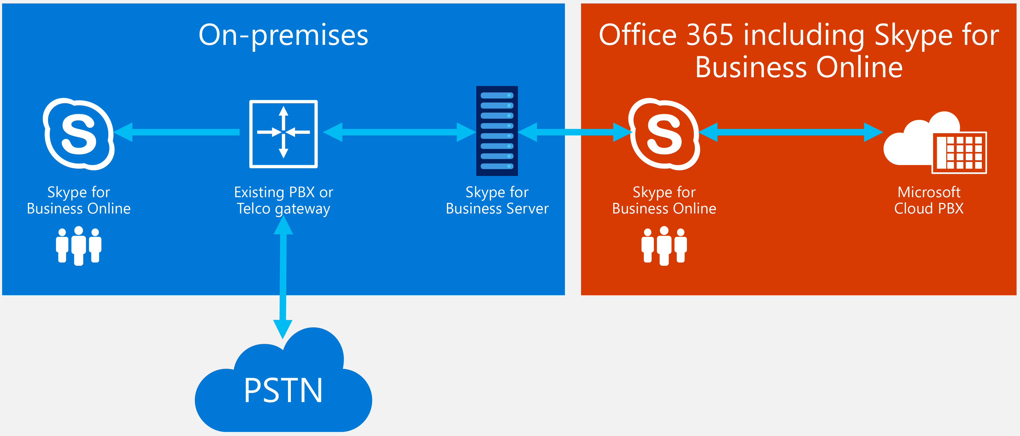
Figure 2. Skype for Business call routing—hybrid cloud
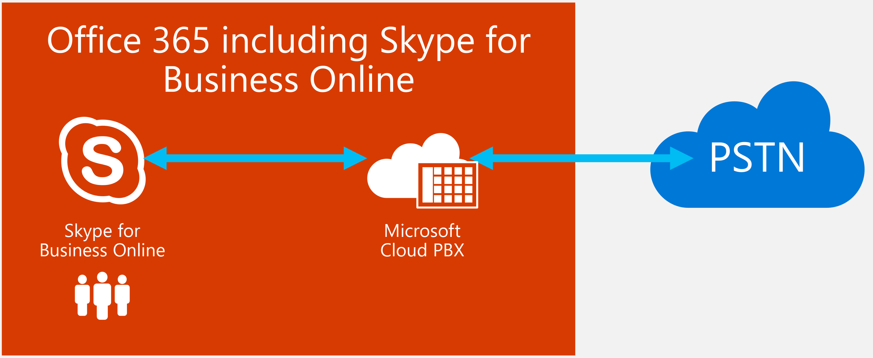
Figure 3. Skype for Business call routing—cloud-based PBX

Identifying unique environmental and market characteristics
Microsoft, in implementing its own brand of unified communications, is of course unique among Skype for Business customers in a few ways. First, we are our own customer. Because IT is part of the same company as the product group that makes the software, we have access to resources and insights that guide our approach and affect our results. This position cuts both ways: we benefit from close contact with internal resources, but we are also compelled to test updates before they are publicly available, which can introduce extra validation cycles. Adhering to these additional steps is a critical best practice for us, as we know the results of our efforts can affect our customers’ productivity in real and positive ways.
The other way that Microsoft is unique in using Microsoft services is that we demonstrate our software for customers in real time. With productivity software like Office 365 and Skype for Business, we want to show the best qualities of those services whenever we use them in a customer’s presence. This added a layer of urgency to make the Skype for Business cloud migration successful.

Deploying Skype for Business in the cloud
Our plan to deploy Skype for Business focused on three primary goals:
- Address complexities in ways that would help us decide which users to migrate and in what order.
- Maintain productivity throughout the deployment, including addressing challenges with validation priorities, task delegation within the product, and dependencies on Microsoft Exchange.
- Follow an orderly deployment time line, including pacing our progress with iterative, phased user migrations, and verifying the quality of service for each phase as we go along.

Choosing the order of user migrations
An important first step in planning our migration was deciding which users would move first.

Initial migration personas
To determine a general order of user migration, we decided to forego (for the moment) detailed considerations of the various complexities and simply ask: Who at the company depends on Skype for Business the most, and who is most affected by service quality and reliability?
To answer this, we built a list of personas—in this case, typical users in unified communications scenarios whose needs were largely defined by their job role and the nature of their work. Putting these personas on a spectrum from most dependent to least, we evaluated each role’s typical work location and use of mobile connectivity.

Figure 4 highlights the three most dependent personas from our research: executives, field sales personnel, and customer service and support (CSS) operators and technicians.
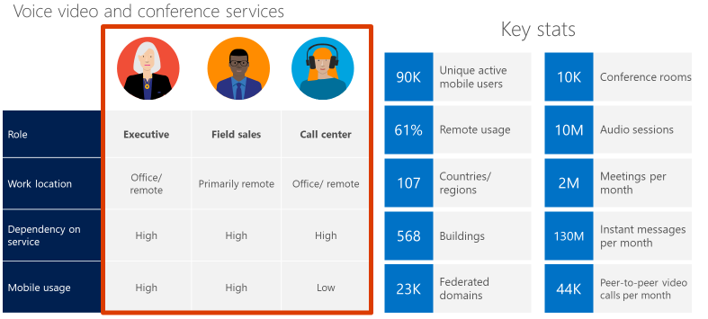
Figure 4. High-priority Skype for Business migration candidate personas and statistics for unified communications usage
We decided to focus on improving service quality for our most challenging group of users, field sales personnel. Out of all our users, they’re the most dependent on the Skype for Business service, for three key reasons:
- They’re often not in corporate offices and they rely heavily on unified communications to do their work.
- As remote users, they don't have the benefit of our stable corporate network, so their calls are often affected by network anomalies. For example, because they often connect over external wireless networks of variable quality, they are affected by quality and reliability issues much more often than corporate network-connected users.
- They use Skype for Business when meeting with customers and prospects, and it’s to our advantage to always demonstrate the best of our capabilities in these situations—in fact, our sales representatives insist on it!
In addition to field sales, we wanted our executives to be among the first to experience the full cloud experience with Skype for Business. Executives are also often remote due to travel and are frequent ambassadors of our products by using them in customer situations. Because these two user personas posed the greatest challenges for our migration, selecting these personas set high expectations for quality and helped us focus. We knew that once we got the service working well for them, all our users in other roles would benefit.

Additional migration personas
In the course of choosing the user personas to target for priority migration, we spoke to users in many roles at many locations around the world. During these conversations, we asked how each user role interacted with Skype for Business, and what types of quality or performance issues they sometimes encountered. These interviews resulted in other personas to consider for the migration, including:
- Executive administrative assistants. Admins who support executives use Skype for Business in unique ways. Most notably, they often schedule and run large meetings on behalf of the executive they support. This task requires special consideration to ensure that the admin not only has full access to the executive’s calendar, but also has a high-quality connection so that the meeting takes place on time, with all participants, and with no technical issues.
Although we didn’t immediately think of admins as “power users” of Skype for Business, their requirements are similar to the executives they support. When an admin schedules and runs an executive conference for up to 200 attendees, it’s critical that the conference go smoothly.
- Contractors and contingent staff. A complicating factor when accommodating the admin persona was that admins often access Skype for Business using laptops or other equipment provided by an outside vendor agency, and the equipment is not necessarily compliant with our best practices for running a Skype for Business conference, including potential issues with wireless network drivers and wireless protocol support.
This reality carries over to all contractors and contingent staff who are a day-to-day part of our business productivity but who are not full-time Microsoft employees. We now support more than 215,000 Skype for Business accounts, and the full-time workforce at Microsoft is less than half that number, so the risk of noncompliance and sub-optimal experience made this persona an important one.
- Bandwidth-constrained users. As a global company, Microsoft has workers in many countries and on most continents. This includes areas that are remote and have far less infrastructure than a city or other technology center. Users in these remote areas have more challenges using Skype for Business, because in many ways these users rely on unified communications to do their work. For these users, we had to consider solutions that would lighten their bandwidth needs so they could participate in calls and conferences the same as their coworkers in other areas.
Not all these additional personas were prioritized to migrate to the cloud, but the time and research we invested to discover these user needs remains valuable as we continue to better understand our customers’ needs and drive iterative product improvements to address them.

Maintaining productivity throughout deployment
Productivity was a key consideration in planning and carrying out the Skype for Business migration. We needed to move users to the cloud without disrupting day-to-day use of Skype for Business across the company. At the same time, we and the product group needed a way to gather feedback from users and address any product-related concerns, such as requests for new features.
The product team established feature crews that worked with us to help respond to user requests while also working to identify and resolve migration issues. The feature crews followed a DevOps model for fielding requests, developing code, and releasing new features into production.
Each time product changes were introduced, however, the user experience was potentially affected. Because of our need to preserve a high-quality experience for our field sales and executive users, we looked for a method that would allow us to implement changes in a way that affected these users least.

Setting up validation rings
Once we decided on the priority of roles to support for the first migration, we needed a plan to balance productivity for all users as specific ones were moved to the cloud and others stayed on-premises.
As with many deployment projects, we chose to delineate groups of user accounts by the environment they would migrate to, with each environment seeing a different set of standards for product stability. For this project, we identified three validation rings, each corresponding to a different environment. We prioritized the user groups into three general environments (or rings), as shown in Figure 5.
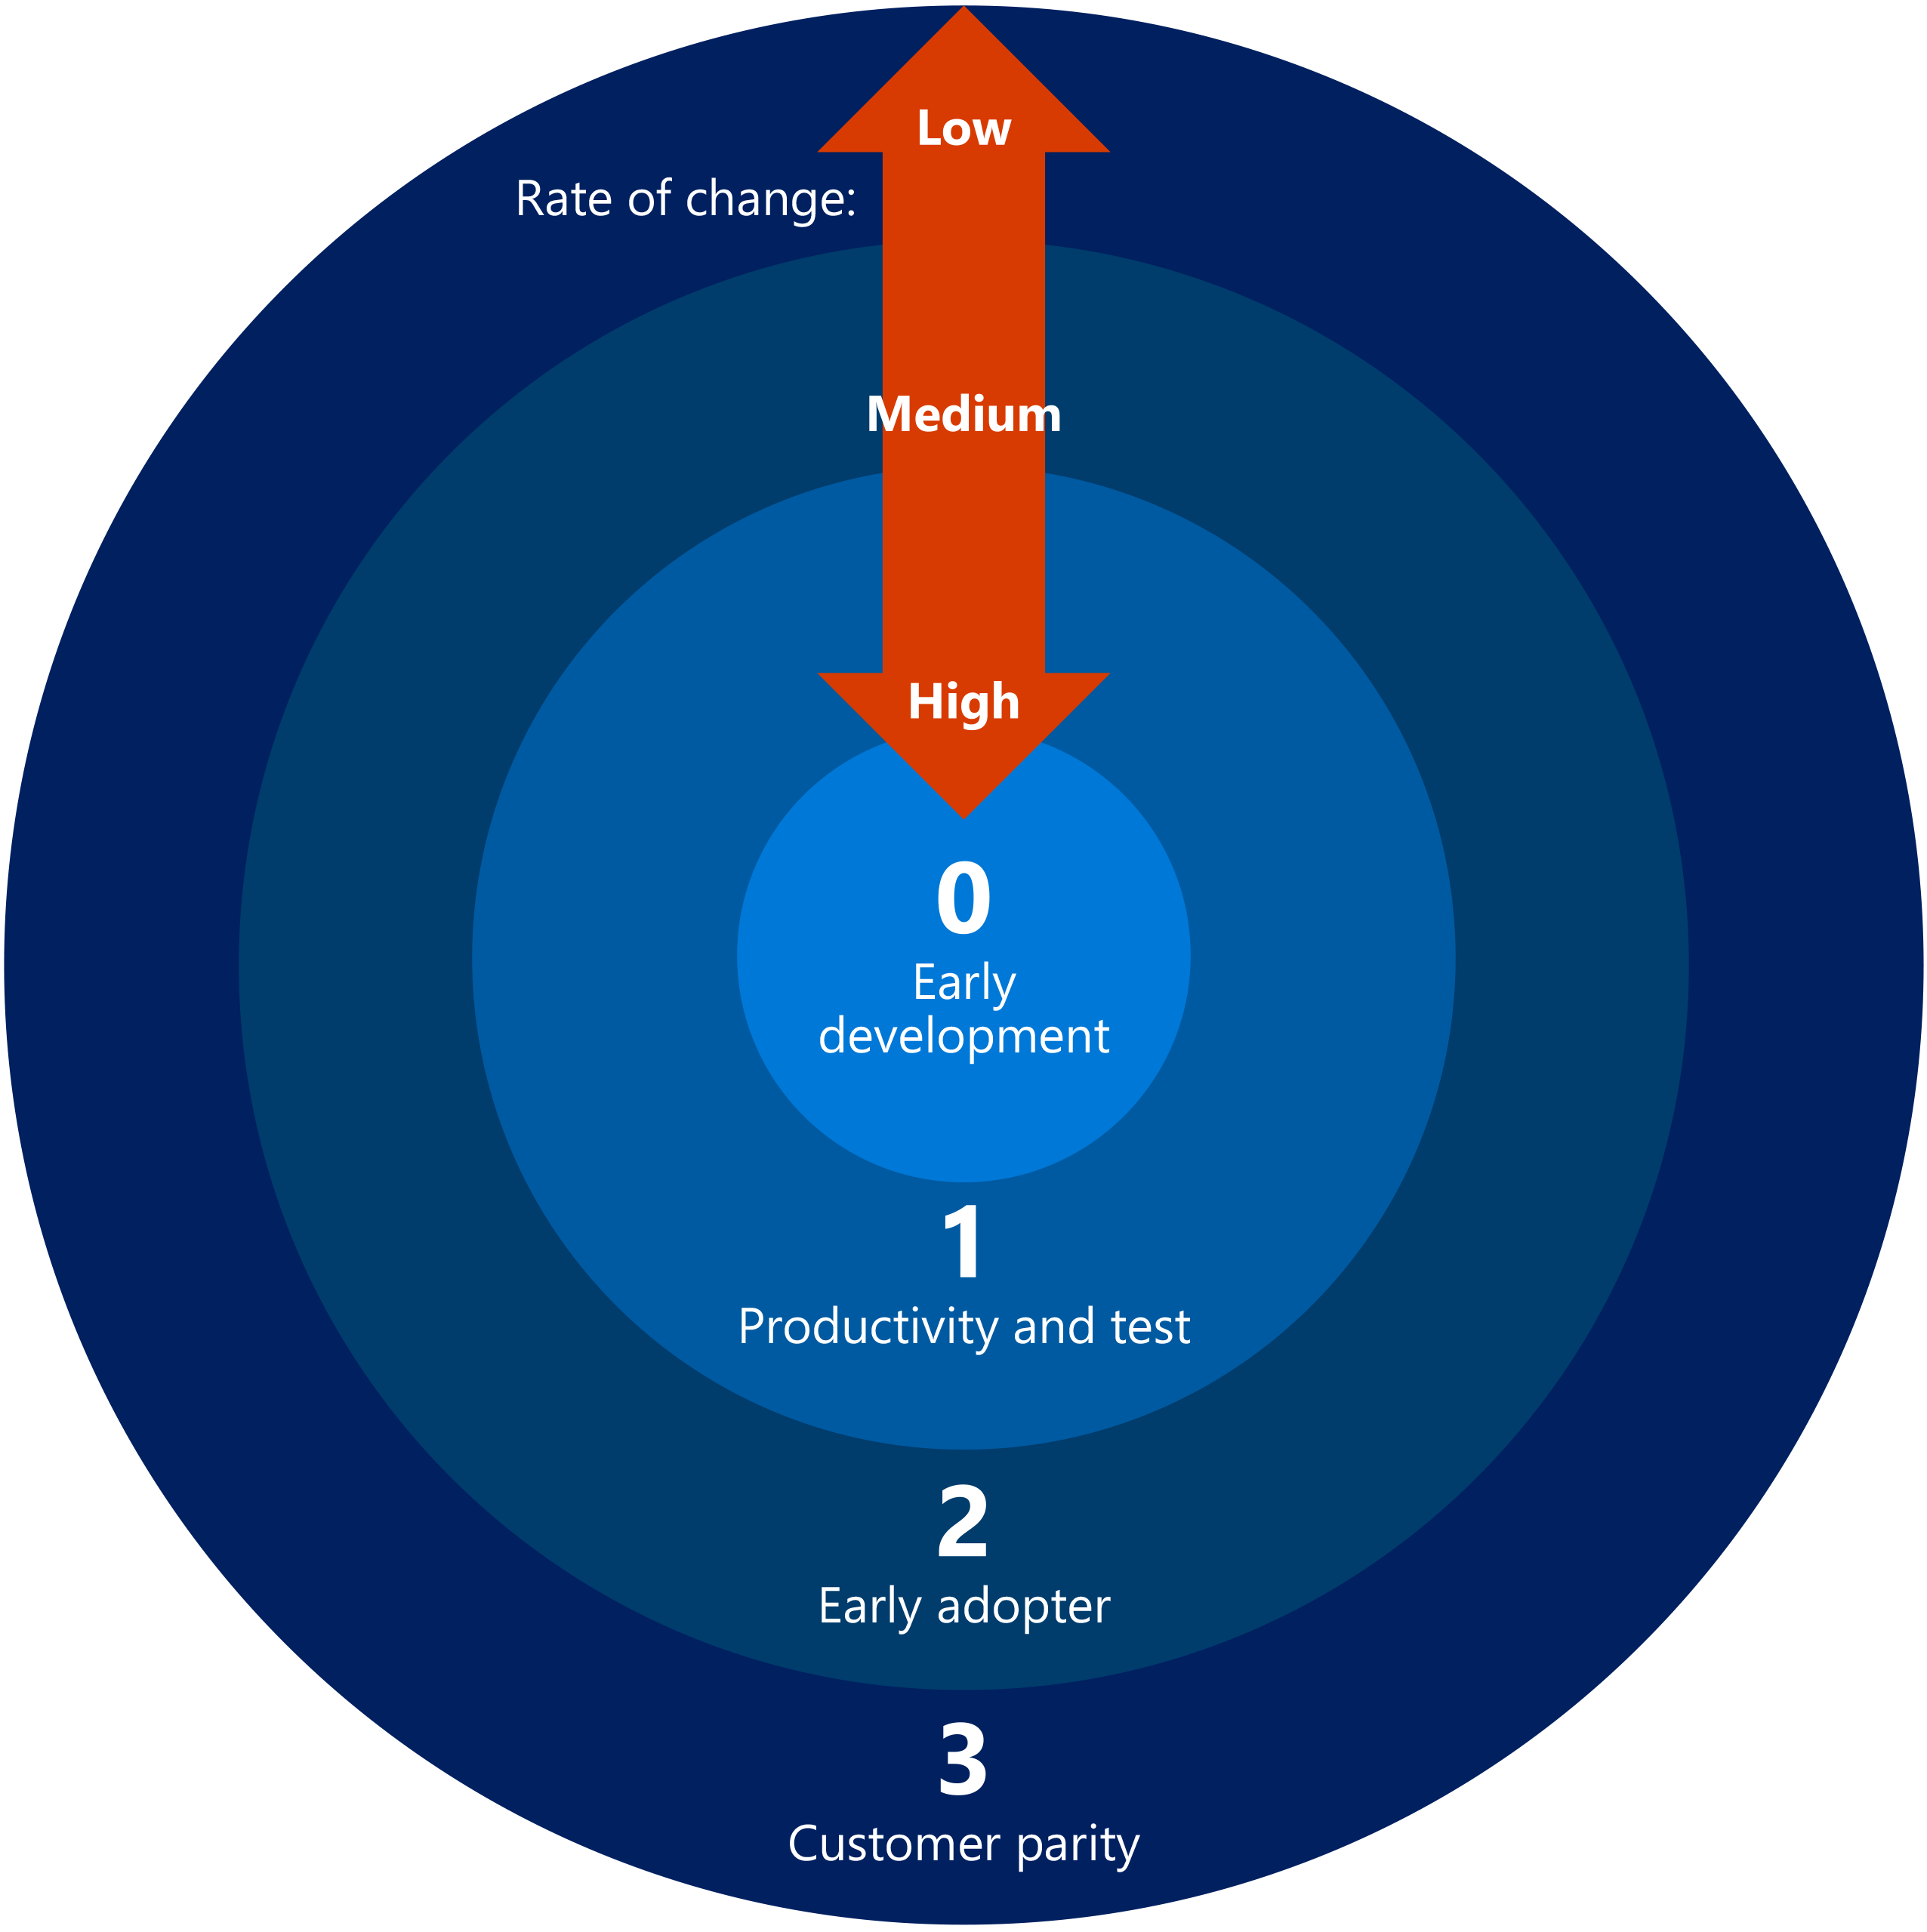
Figure 5. Skype for Business validation rings for moving to the cloud.
- Ring 0 was our early development ring. This group saw a high rate of change because the product was updated as often as once per day. The environment is chaotic by design—it offers a way to test each build with users, and when a build was stable, it could be moved to the next ring. Only product group and IT developers were in Ring 0.
- Ring 1 was our productivity testing ring. Stable product builds moved from Ring 0 to here, where we could test them for feature performance validation and scale. Because we considered the builds stable, we felt comfortable locating most of the company’s users in this environment. However, the rate of change was high enough that Ring 1 still posed risks for our highest-priority users. Ring 1 was enough for maintaining most day-to-day productivity tasks, but a field seller or executive presenting a large meeting or customer demo was likely to experience technical difficulties.
- Ring 2 was our early adopter ring, where we released builds to user groups who were eager to use the new functionality enabled by cloud-based Skype for Business and were interested in giving feedback to the IT and product development teams. Early adopters are an important part of our product testing because they verify call quality and other service performance characteristics. Early adopters were encouraged to use our help desk to report issues, enabling us to test our quality assurance processes by monitoring and addressing help desk activity.
- Ring 3 was our customer parity ring, not only because we prioritized it for using our product with our customers, but also because we considered it to be the environment we wanted to most reflect what our customers who buy Skype for Business will experience for themselves. This protected ring saw a much lower rate of change than the other rings because we didn't update it with new features and functionality as often as Rings 0 through 2. By the time a build was released in Ring 3, we considered it very solid and ready for customer-wide release. This was the validation ring to which we prioritized migrating our field sales and executive personas.

Coordinating delegation and other dependencies
Migrating Skype for Business users to the cloud entails coordination with other Office 365 Enterprise E5 components. At the same time, we were migrating Skype for Business users to the cloud, we were moving users to cloud-based Microsoft Exchange. Because Skype for Business relies on Exchange inboxes and Exchange user identity factors for voice and conferencing services, the success of our Skype for Business migration depended on the Exchange cloud migration, specifically:
- Exchange Online dependencies. Skype for Business users can only access all Exchange resources if their Exchange mailbox is also in the cloud. Therefore, any Skype for Business users we moved to the cloud needed to be fully in the cloud, using Office 365 for all Exchange and Skype for Business services.
- Delegation dependencies. During our first Skype for Business persona investigations, we learned that the delegation feature in Exchange was an issue for some users. Often, executives delegate control over their email and calendars to their assistants. But for delegation to be successful, both the exec and the admin must be in the same Exchange environment—that is, they must either both be on-premises or both in the cloud. If this dependency isn’t satisfied, delegation between the accounts is broken and admins can’t do their jobs.
Satisfying the dependency for Exchange and SharePoint migration efforts was a matter of coordinating the lists of users being migrated in each project. Tackling the delegation dependency took more work. For one thing, the delegation relationships between executive and assistant accounts were not documented, and so it fell to us to research each of the user groups to find and track dependencies. What we then encountered was the fact that admins often delegate their schedules to other admins, who sometimes delegate them again, and so on.
We created Microsoft Excel-based tools to help gather this information. The final data set that we manually captured was a spider web of delegation relationships among user accounts. We used this data to guide our detailed migration schedule. At certain points, delegate relationships were no longer accurate, requiring some cleanup of the data along the way. The effort was required for all three validation rings, because delegation dependencies were independent of the product version and the environment in which it was released.

Moving users to the cloud
Our user migration began in late 2013 with an executive mandate to enable 30,000 users for cloud-based Skype for Business. We used the hybrid cloud model to reach this goal, allowing many of our users to benefit from cloud-based conferencing while keeping their on-premises access to voice services until they move fully to the cloud. Several months later, we began implementing Office 365 Enterprise E5, and our journey to a full cloud-based Skype for Business implementation was achieved for a subset of those first users. That number continues to grow, with more than 95,000 users now fully in the cloud.
Nearly all of our first cloud users were in North America. As we gradually migrate our international users, we’re able to eliminate the on-premises infrastructure in other countries/regions and datacenters. Later in this document, in “Getting to a multinational cloud,” we discuss some of the geographic factors that influenced our decision to separate the clouds in this way, and to deploy them in this order.

Figure 6 shows the process we followed for adding cloud-based Skype for Business to our existing on-premises Skype for Business environment, and move users to the cloud at our own pace.
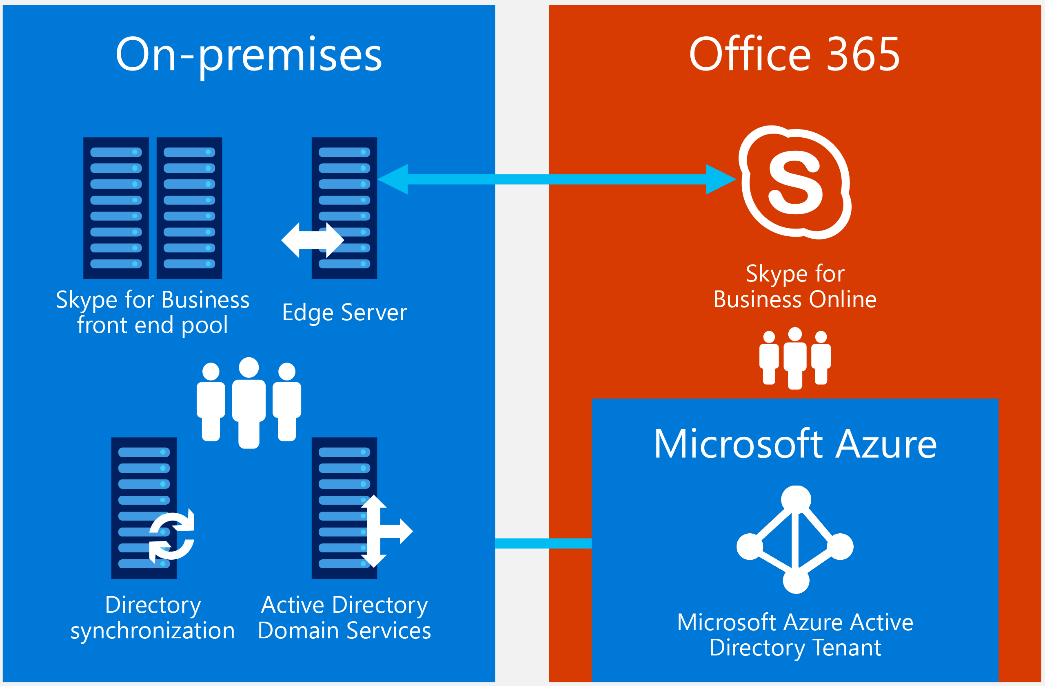
Figure 6. Migrating Skype for Business users and services to the hybrid cloud
Throughout the process, all users shared the same session initiation protocol (SIP)—in this case, microsoft.com. As users were migrated, they gained the ability to integrate with other Office 365 services, including Exchange Online and SharePoint Online, as well as take advantage of cloud-based services like Skype for Meeting Broadcast, which optimizes Skype for Business for large meetings.
As with many migrations, deployment is careful balance between efficiency and quality assurance. We aim to move users quickly, but we also don't want to jeopardize their productivity and overall high-quality user experience. Our team developed migration tools that help move batches of users and test the success of each move so that users don’t experience failure or inconvenience when they run Skype for Business for the first time in the cloud. We also adopted these strategies for staggering the migration strategically across user groups, to ensure that we get useful feedback from those users:
- We migrated test accounts first, followed by early adopter accounts, so that any issues with the migration did not significantly affect production users.
- When preparing to migrate accounts in a specific geographic area, we migrated the IT managers in that area before other users, allowing us to test our communications and feedback loop before wide release.
- We worked closely with help desk to make sure that migration issues were promptly addressed.
- We scaled our call quality telemetry to measure the effects of migrating users to the cloud, so that IT managers and support teams could verify that customer experience, service reliability, and end-user satisfaction met the required levels for our internal protocols.
And in the spirit of optimizing the user experience while being our own “first and best” customer, we also used tools to monitor service performance and gauge user sentiment. The experience of identifying and resolving issues led us to refine the Skype Operations Framework, which offers programmatic guidance to help customers successfully plan, deploy, and run Skype for Business in multiple configurations, including in Office 365 Enterprise E5 and the hybrid cloud.

Addressing technical challenges
As the migrations proceeded, we faced various technical challenges with infrastructure requirements, Windows Active Directory components, and service limitations beyond our corporate network. We set up tools and communications plans to address these challenges and aligned our efforts to support our vision of a single, multinational cloud where three geographically separate cloud deployments function together as one.

Upgrading networking and other infrastructure to support capacity
In 2013, around the time we launched the Get to Green initiative, our Skype for Business users began experiencing errors. They couldn’t join meetings, particularly at peak times of day like at the top of each hour. Our corporate network infrastructure couldn’t support the demand. We needed to increase our capacity, which meant upgrading our data center circuits. We also removed firewall latency bottlenecks, ensured adequate bandwidth, and added tools to help us manage key configurations, such as making sure quality of service (QoS) is enabled on all devices.
As we migrated Skype for Business to the cloud, we further addressed bandwidth issues to accommodate recent trends, including bring-your-own-device (BYOD). Although the bandwidth requirement for unified communications is relatively low, the increasing presence of bandwidth-heavy traffic—such as streaming video—affects the performance of Skype for Business. Additionally, firewall packet inspection on our network takes an added bandwidth toll.
Our network needed upgrades to efficiently transfer and process those packets at firewall locations, so it could support smooth, secure Skype for Business operation. To remedy this situation, we:
- Increased our dedicated bandwidth through all edge and core routing and network hardware.
- Mitigated the risk of shared IT outages by migrating datacenter users to the cloud.
- Ensured the use of network QoS settings, including DSCP 46, that gave priority to voice traffic first and video traffic second.
- Opened the appropriate ports to provide optimal performance.
In addition, users increasingly connect to our unified communications service with wireless, although our networks were designed to support mostly hard-wired connections. The wireless infrastructure in our buildings created a significant bottleneck. The source of these issues was a combination of factors, starting with outdated wireless protocol specifications, but also because our existing firewall devices allowed only 1 MB connections for incoming and outgoing traffic.
For each bottleneck factor, we took these steps to increase bandwidth and throughput:
- Wireless protocols. We upgraded our building wireless networks globally from 802.11n to the faster 802.11ac standard.
- Radio bands. We configured our wireless networks to preferentially select the 5.0 GHz radio band over the 2.4 GHz band.
- Wireless area network (WAN) congestion. We upgraded our WAN access points in many facilities to support the growing demand for wireless services on more supported devices.
- Firewall devices. We upgraded to Microsoft IT-approved access point devices that support the new wireless standards, and began phasing out incompatible devices.
- Device settings/support. We upgraded all our managed clients to Windows 10, which has improved wireless drivers.

Transitioning from SIP trunking to cloud-based PBX
The evolution of voice and teleconferencing services has led from circuit-based PBX technologies and pay-per-minute call bridge services, to VoIP services where external carriers translate traditional PBX technologies to IP-based telephony. The role of these carriers diminished as companies modernized and became more self-sufficient, but the carriers were still necessary for making the session initiation protocol (SIP) routing and translations required for unified communications. Even in the hybrid scenario at Microsoft, where users retained the Office 365 Enterprise E5 service to do teleconferencing, users kept PBX-based voice services and SIP trunking from external carriers because the logistics of porting phone numbers from the outgoing carrier accounts to Azure took too much time.
The move to fully cloud-based unified communications, where Azure datacenters provide all voice and conferencing services using cloud-based technologies, takes this transition even further. Migrating Skype for Business to the cloud has also meant migrating to a whole new paradigm for how unified communications is managed as a service, and how our reliance on external carriers is lessened to practically zero.
And while this scenario is unique because Microsoft happens to be its own customer for these cloud-based services, for the typical Skype for Business enterprise customer it will be the new normal; instead of paying separately for a carrier to manage these services, the costs are provided at scale as part of your cloud subscription.
Our cost savings from this transition are still being accounted for, but in general we expect to save in these areas:
- Reduced expenses from external carriers for voice and conferencing services, relative to the cost for Azure to provide the same services in the cloud.
- Decommissioning old PBX hardware that is no longer needed represents significant savings from equipment updates and maintenance that are no longer needed.
- Additional savings from value-added services like Skype Meeting Broadcast, which enables large broadcast (one-to-many) meeting services without engaging a third-party streaming media vendor.

Accounting for inherent service limitations
Because Skype for Business is an access-anywhere technology, we can only manage it to the edge of our infrastructure. Yet more than 50 percent of our users are outside of our datacenters. In these cases, we cannot control the environment, but only influence user behavior. It was important to account for this fact because we set expectations for service quality, both for our own metrics and for the user experience.
To overcome these limitations, we used a three-part approach:
- User training. We had user education campaigns and released promotional videos to coach remote users on how to get the best Skype for Business performance.
- Quality monitoring and sentiment tracking. We refined our use of quality monitoring tools available within Skype for Business, and continuously collected user feedback in the form of quick-response user surveys following each call.
- User self-service. As much as possible, we enabled user self-service to fix service issues as they occurred, and encouraged them to select peripherals from a list of approved devices.
Figure 7 shows an example of some guidelines we share to help users achieve a positive Skype for Business experience, wherever they are.
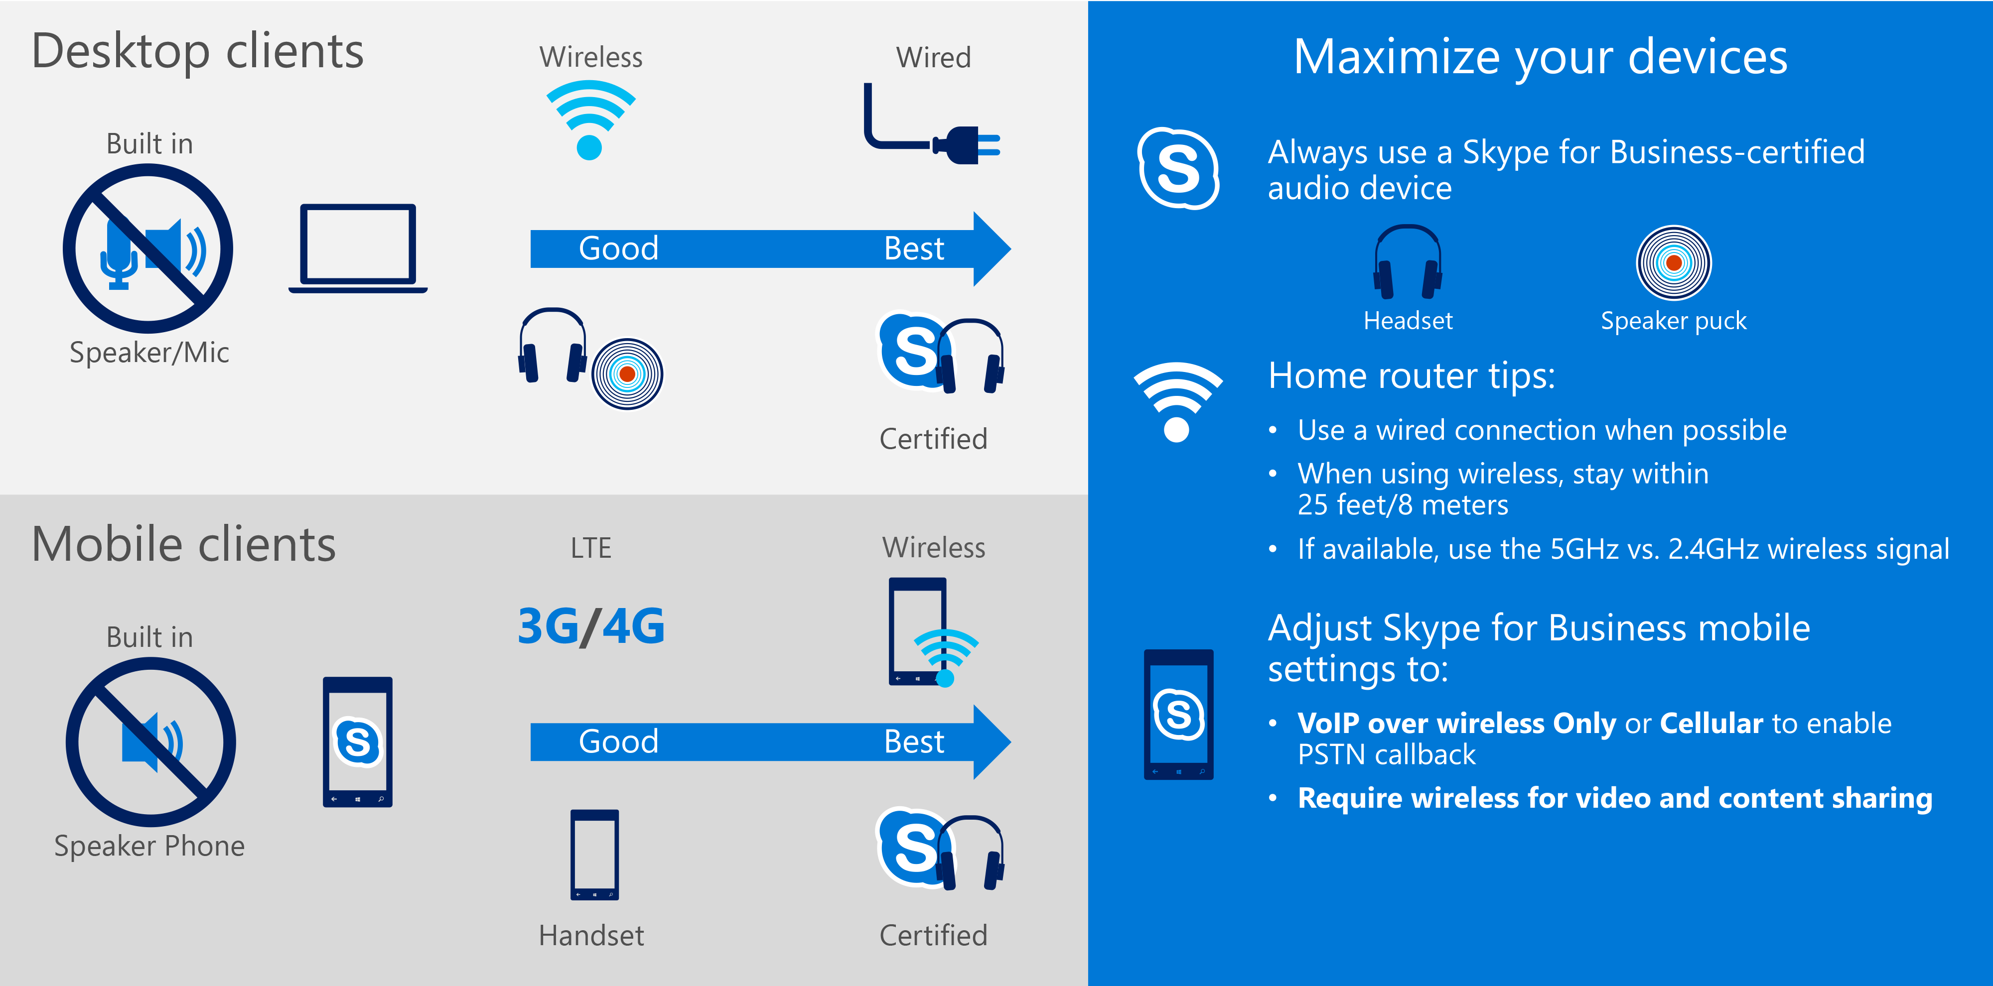
Figure 7. Guidance for achieving a positive Skype for Business user experience
As more supported mobile devices were propagated throughout our network, we also noticed that user reports of lag time increased. To address this issue, we:
- Upgraded access for iOS and Android devices.
- Added PSTN callback functionality, so users having difficulty joining meeting audio can have Skype for Business call their device.
- Added optional lightweight clients for users who have severe bandwidth limitations.

Getting to a multinational cloud
As described earlier, our initial migration moved Skype for Business users in North America to the cloud. However, with more than 200,000 users around the world, Microsoft needs to offer uniform cloud-based service to all users, including those on other continents.
The solution ended up being a natural extension of our first cloud solution: using the Office 365 Enterprise E5 hybrid architecture to enable Skype for Business deployments in other areas. By building regional hubs for cloud-based conferencing using local dial-in numbers for attendees, while maintaining on-premises voice services for all users so that their telephony benefits continue unencumbered by the complexities of porting existing phone numbers, we have been able to achieve cloud benefits for our global users as we incrementally migrate them to the hybrid solution. To date, we have migrated more than 10,000 user accounts in Europe, the Middle East, and Asia, and more than 5,000 accounts in the Asia-Pacific region.
As we looked ahead to fully cloud-based unified communications, we identified other technical obstacles. The Azure datacenters that run cloud services for Skype for Business did not automatically allow users from different cloud environments to interact. Specifically, the Microsoft Azure Active Directory (Azure AD) forests at each cloud datacenter did not share policy information in ways that allowed users in one location to communicate with users in other locations. This kept us from our goal of having a single, multinational cloud that offered seamless connectivity with other cloud, on-premises, or hybrid environments.
To solve this problem, we developed relative identifiers (RID), an Azure AD mapping system that runs locally and spans all Azure AD forests in the Skype for Business cloud-based datacenter. RIDs translate Azure AD policy information to allow user-to-user communication across locations.
Our work to implement and perfect our multinational cloud approach is ongoing. Once we have the capacity for a truly global Skype for Business cloud, all our users will be able to connect seamlessly. And future versions of Skype for Business will route traffic across disparate forests, fully enabling cloud-based users to connect with on-premises users and allowing users to host meetings in Azure AD forests other their own.

Developing tools and promoting communications
Developing tools and planning communications are important aspects of any enterprise deployment. For this project, we developed these tools to help with our migrations:
- HP Network automation. This third-party tool ensures that routers and switches in datacenters run in a compliant configuration, and helps to ensure QoS end-to-end. We use it to analyze our network and server infrastructure to determine if we need to increase capacity for availability and reliability. This tool is supplemented by an internal tool we developed, which ensures that all devices run gold code and meet our capacity and compliance standards.
- Unify Square Power Monitor. We use this tool to measure quality during synthetic transactions by setting up probes and testing accounts in datacenters.
- RIDs. This internal technology is helping us bridge the various Azure AD forests that populate our Azure datacenters so that cloud-based Skype for Business users in any cloud can interact with on-premises users and with each other.
- Deployment automation tools. We accelerated our migration to cloud-based unified communications through Skype for Business deployment automation tools and scripts.
- Delegation relationship mapping tools. When we encountered the challenge of aligning executive user personas with the admins to whom they delegated their unified communications capabilities, we built an Excel-based toolset that helped find and track these complex user relationships.
- Quality monitoring and management tools. We use the Call Quality Dashboard, part of the Skype for Business service, along with internal tools like Rate My Call and Skype@Microsoft, to see call quality and user experience issues in every company building.
- Skype for Business Admin Center. Skype for Business in Office 365 Enterprise E5 offers a single, unified management console that is optimized for managing on-premises, cloud-based, or hybrid deployments. Administrators can use the Skype for Business Admin Center to manage settings.
For communications, we learned several new best practices:
- Establish a clear format and protocol for end-user communications and incident communications.
- Avoid sending incident communications too quickly—sometimes by the time the communication is received, the issue has already been resolved and the message just creates confusion.
- To get user perspectives, incorporate Yammer for social listening, and participate in YamJam events.
- Proactively offer training, tips, and guidance to all user groups, including end users and IT managers.
- Offer methods other than email for getting incident updates to users, such as posting to portal dashboards, Microsoft Teams, or Yammer.

Monitoring service health and focusing on quality
Our best practices as an enterprise IT organization compel us to constantly seek new ways to provide for the health and quality of the services our business users depend on. To make the Skype for Business migration truly successful, we needed to make sure these vital components were part of the solution we provided, and to achieve that goal, we used tools and programs to engage our users and IT managers as directly and productively as possible.

Refining and optimizing call quality management tools
To help us monitor system health and diagnose network infrastructure issues affecting call quality, we developed the Call Quality Dashboard and the Call Quality Methodology.
The dashboard launched with Skype for Business Server in 2014. The dashboard monitors and measures all Skype for Business usage, whether point-to-point conversations or larger conferences, that originates inside or outside our corporate network using wired or wireless connections. It offers a step-by-step approach to improving call quality using the telemetry included in the dashboard, helping us to speed up investigations, quickly resolve issues, and drive Skype for Business improvements across Microsoft. Figure 8 shows the Call Quality Dashboard.
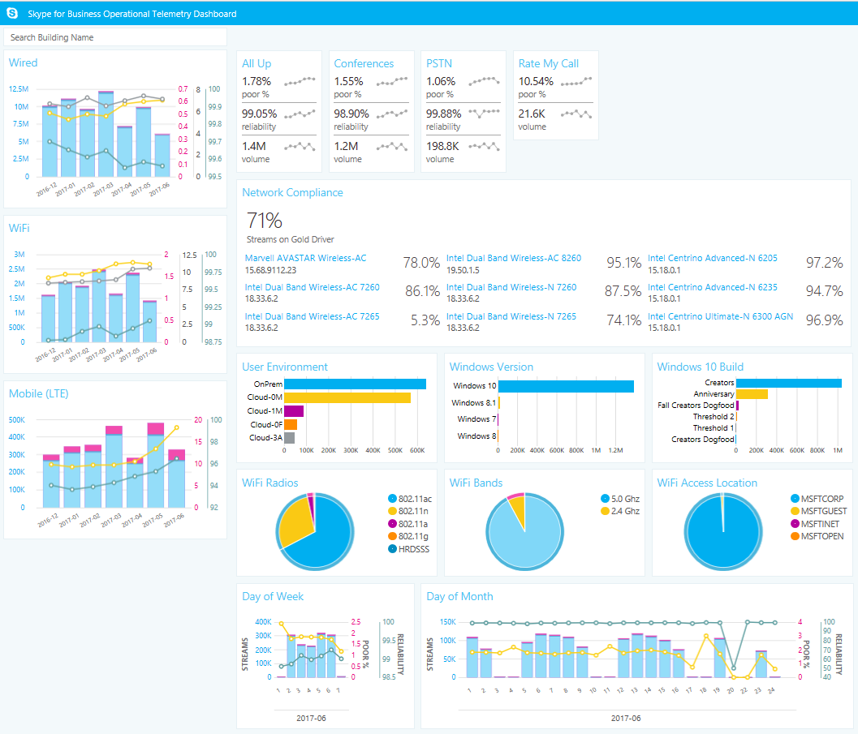
Figure 8. Snapshot of the Call Quality Dashboard
The dashboard connects to our quality of experience database and uses a metric called poor call rate as a key performance indicator, rating calls from 1 to 4 based on packet loss and jitter. Using the dashboard, Microsoft IT managers can drill down into these metrics—even to the individual call—to ensure that we’re delivering the best user experience at each location or building. Measurements taken by the dashboard look at:
- Service health. For both wired and wireless network infrastructure—both internal and external—we look at poor call rate to see how healthy the service is. For server-to-client or client-to-client call streams, it provides a mean opinion score (MOS) score for packet loss, jitter, ratio conceal, and round-trip times.
- Client health. For each client device, we look at information about hardware, settings, client version, wireless driver, and peripheral devices, such as headsets and speakerphones. It also shows us if a device complies with our current standards.
This is a partial list of the data tracked in the dashboard:
- Quality of wireless connections.
- User-provided data on call quality.
- Network driver status and compliance.
- Quality of service for conferences and telephony.
- Lists of users affected by poor data streams.
- Lists of certified audio devices in use.
- Service reliability using status from before and after a user joins a meeting.
- Wireless technologies in use.
- Types of wireless networks and specific about radio band connections.
- Network adapters in use, broken down by volume and type.
- Status of incidents raised by users and IT managers.
- Feedback from IT managers on the dashboard experience.
Early versions of the dashboard gave a wealth of helpful information, but presented in a way that many users found complex. Refinements have aggregated many data points into easy-to-read charts where IT managers can see, at a glance, where problem areas might be in their buildings. It lets them drill down in particular areas of concern. For example, Figure 9 shows a recently developed dashboard that focuses on Surface driver compatibility in a Skype for Business environment.
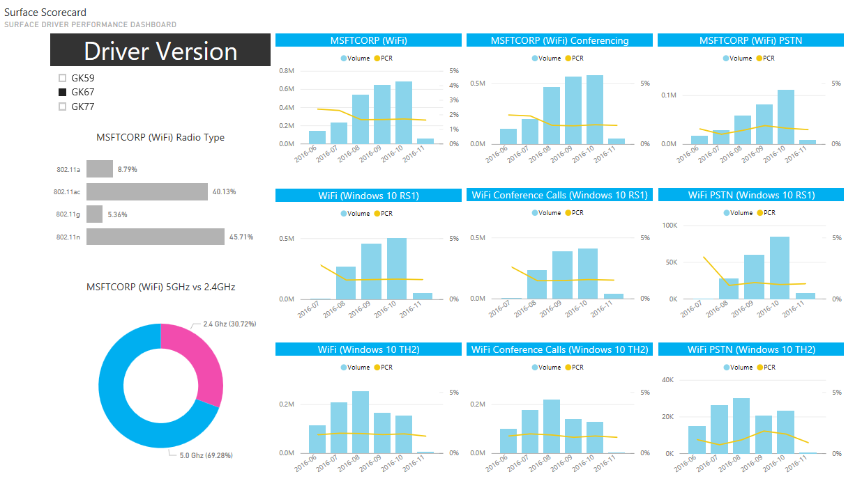
Figure 9. Surface compatibility details in the Call Quality Dashboard

Incorporating user sentiment
User sentiment is an important input to maintaining service health. Our Rate My Call tool randomly invites users who have just completed a Skype for Business call to answer a simple questionnaire, shown in Figure 10, about their audio experience.
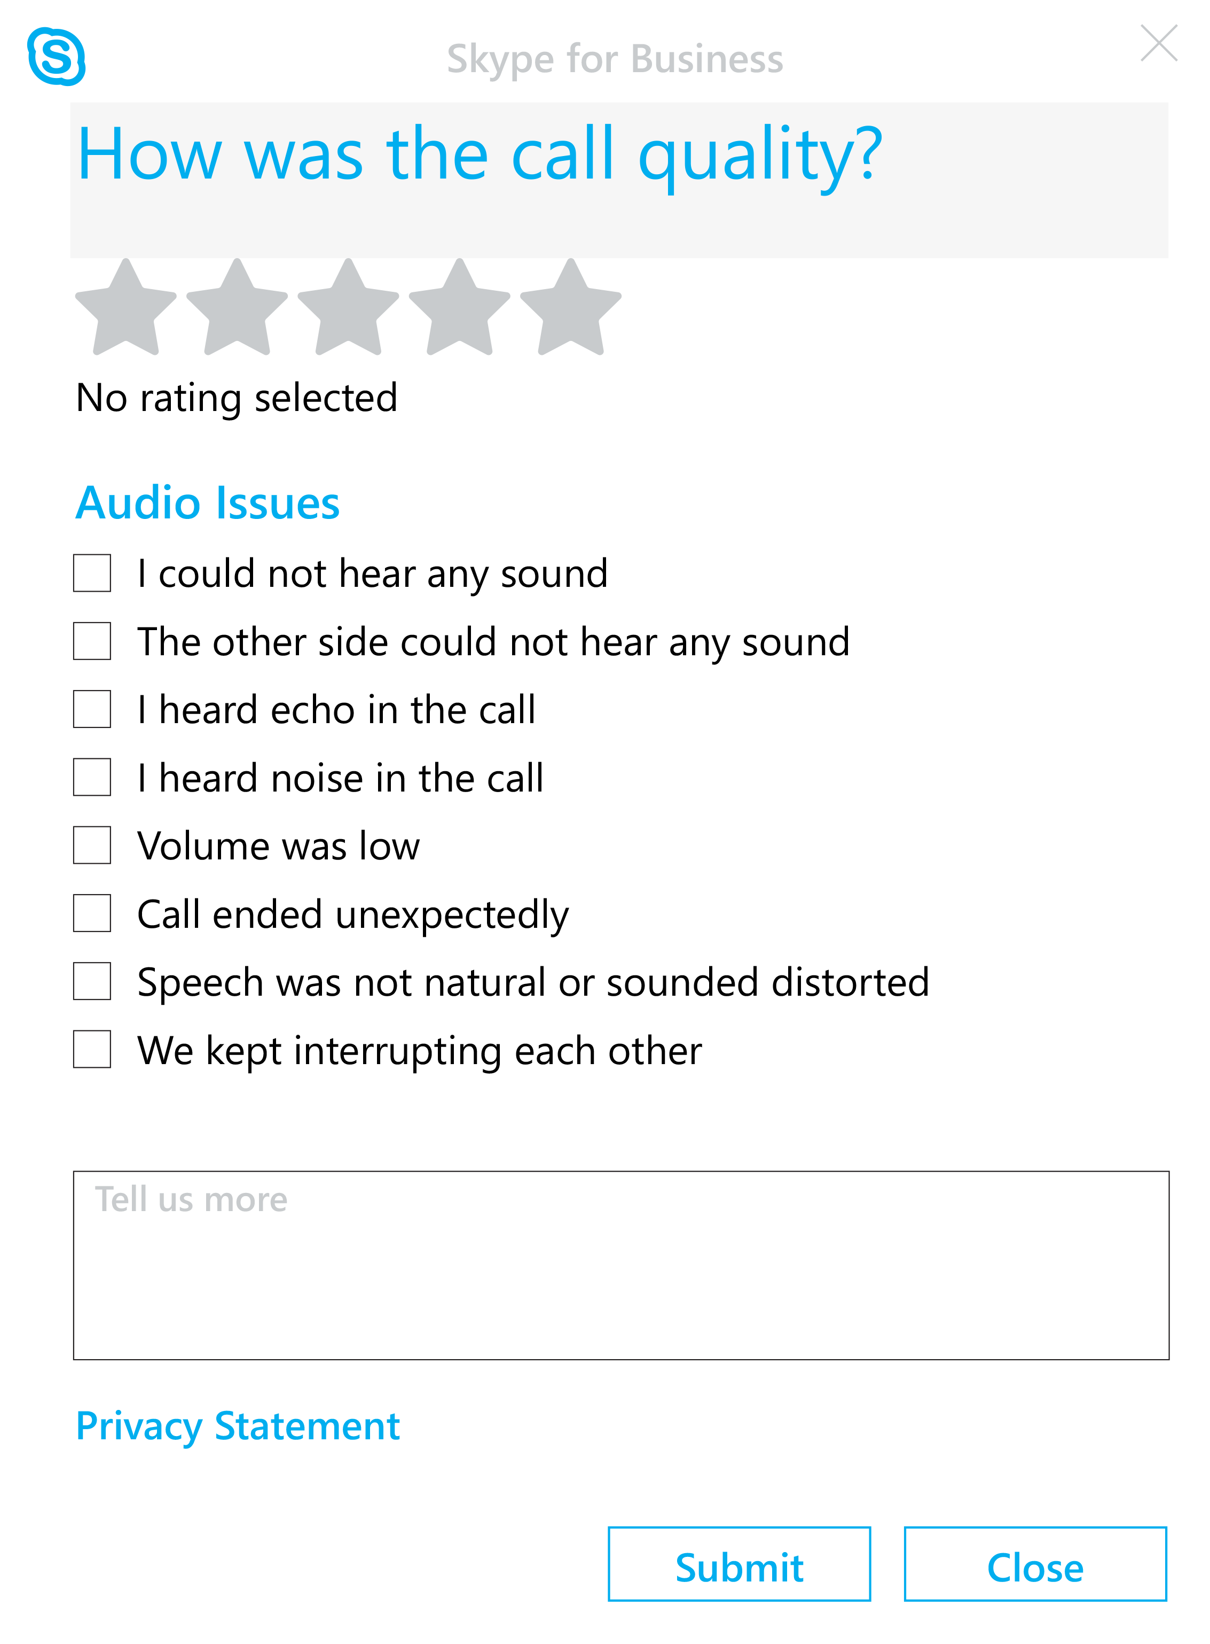
Figure 10. The Rate My Call questionnaire for gathering user sentiment about call audio quality
By encouraging users to participate in Rate My Call and then using the Call Quality Dashboard to monitor the running score that aggregates users’ responses, IT managers get an instant view of the state of user satisfaction with Skype for Business. When a manager sees a spike in call quality issues, they can investigate and take action right away to restore productivity to users who are experiencing failures or delays.

Conducting site investigations
As part of our listening and education tours, we train IT managers to use these tools to address issues in their buildings. They can improve call quality by fixing incompatible drivers and client versions, underperforming devices, and insufficient network bandwidth. By using the dashboard and methodology to isolate and understand specific issues on a per-building basis, we have reduced the poor call rate from 8 percent to less than 2 percent globally.
To conduct a site investigation, the IT manager views the Call Quality Dashboard and drills down in the data as needed to uncover the source of an issue. Once they know the source of an issue, they can remediate it.
Color-coded trend lines in the dashboard graphs represent the poor call rates on wired and wireless networks. When these lines are all trending down, the service is getting healthier. Other graphs highlight that the number of calls with a poor call rate exceeds the target desirable state. In this case, the IT manager can get more detail, such as what type of calls are involved, the network device drivers being used, the wireless hotspot in use, the wireless channel, and so forth. They can also compare observational data with call quality ratings provided by users to learn about and investigate any discrepancies.
The relevance of site investigations at Microsoft is clear when we compare a few examples from our experience. In early 2014, one of our New York buildings experienced an extreme slowdown in unified communications functions for its regional sales staff. Upon researching the problem, we discovered that there was a driver compatibility issue on the Surface Pro 4 devices that had been recently distributed to all sales staff. Once we had a diagnosis, it was a short path to updating the drivers and fixing the problem. However, it took us months to diagnose the problem because the early dashboard was our only tool. Despite the volume of useful data, we lacked a way to easily and visually grasp the scope of the issue and its contributing factors.

By comparison, some of our IT team recently met with a CIO at the Microsoft Executive Briefing Center to discuss Skype for Business. The company was experiencing serious difficulties with Skype for Business performance. Using a Surface device, we helped the CIO connect to his company’s local service quality database and interpret the data that appeared in the Call Quality Dashboard. The dashboard revealed that the company was running very few Windows 10 devices and had no QoS enabled for prioritizing voice packets on its network. Within a few minutes, working with our team and the data we viewed together, the CIO had several meaningful approaches to fixing his problem.

Promoting user self-service
To engage users and efficiently funnel their feedback into Skype for Business service improvements, we created an internal SharePoint site called Skype@Microsoft that gives users ways to send us feedback and requests. The page is also the starting point for other Skype for Business topics, including community engagement, information, other self-service tools, and alerts.
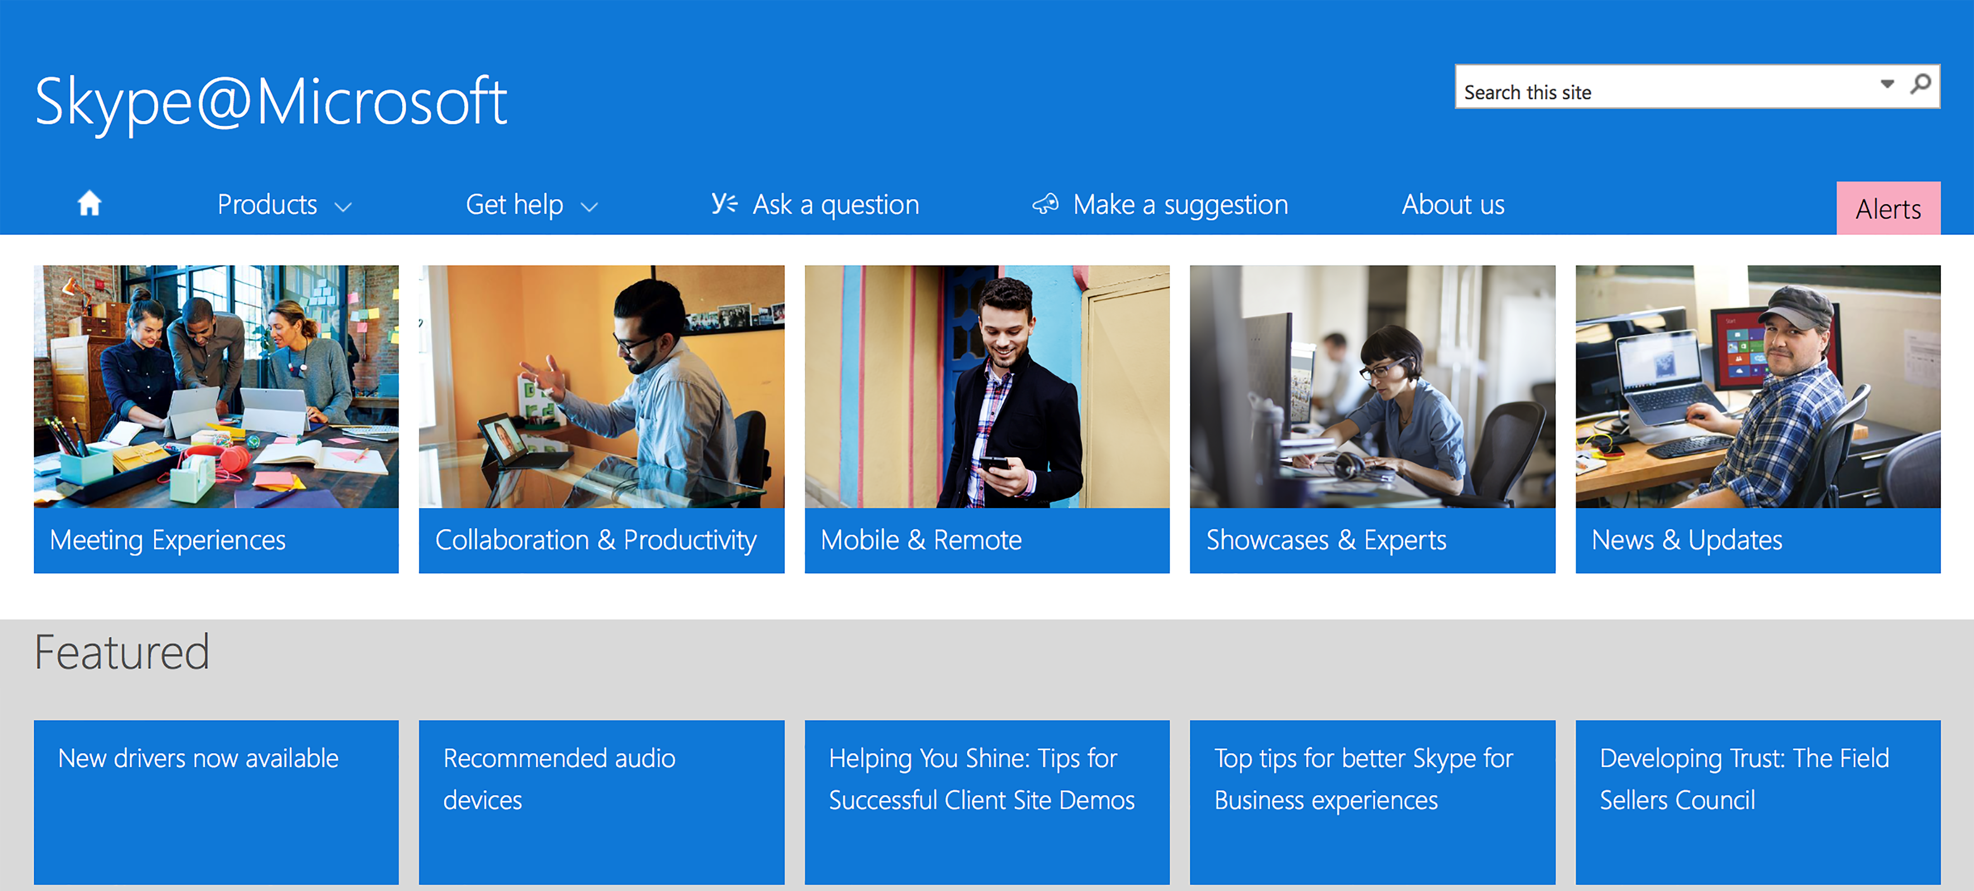
Figure 11. The Skype@Microsoft user self-service website

Results, benefits, and best practices
To date, we have deployed cloud-based enterprise voice to 139,000 users, 115,000 of whom use our hybrid cloud environment and the remaining 24,000 who are fully in the cloud. Our cloud-based users conduct 44,000 peer-to-peer video calls and send more than 130 million IM messages each month, and 23,000 partner accounts are authenticated and federated into our Skype for Business network. Many of the savings and benefits of this change have yet to be realized, but the next two sections detail some of the progress we’ve seen so far.

Cost savings
Migrating to PSTN conferencing and enterprise voice has saved nearly $124,000 per day. We avoid 45,000 trips per year, which represents a $92 million savings. Some of these data points show the transformation of unified voice and what it brings in cost savings and productivity gains to our business.

We calculated these savings based on an early adoption benchmark of 127,000 enterprise voice users, 50 percent of whom were remote, along with the usage metrics shown in Table 1. Note that your company’s costs and savings—including implementation activities such as decommissioning a PBX infrastructure, deploying Skype for Business, and acquiring licenses—may differ from those of Microsoft.
Table 1. Overall savings
Skype for Business | Detail
Conferencing savings realized | Nearly $124,000 per day
Travel cost savings realized | $92 million per year (45,000 trips)
Enterprise voice adoption | 127,000 users
IM messages hosted | More than 130 million per month
Video calls hosted | 44,000 monthly peer-to-peer video calls
External partners federated | 19,000 authenticated and federated partners
Remote use | More than 50% are remote participants (not on corporate Microsoft network)
Audio/video savings realized | $8 million per year
International calling tolls savings realized | $2 million per year

In the past six years, while migrating to cloud-based PBX, we’ve decommissioned 70 percent of our owned PBX hardware—that’s 141 PBX systems. This represents a savings of more than $2,500 per day, for a total of $4 million so far. At the same time, our enterprise voice sites have grown by 238 percent.
When we take advantage of unlimited audio conferencing to eliminate per-minute costs that third-party audio conferencing providers charged, the realized value has been dramatic. Overall, we’ve seen a 95 percent reduction in audio-conferencing costs, which translates to $8 million per year.

Benefits of the migration experience
We have three categories of benefits from our migration experience: people, process, and technology.

People benefits
- Improved user experience. With the recent network improvements and tools like the Call Quality Dashboard, IT Managers can assure users of a better Skype for Business experience and address issues on a per-building basis as soon as they arise.
- Increased business productivity. With a higher level of control over Skype for Business service quality, IT can focus on helping workers maximize their productivity using unified communications tools. This includes providing a better user experience for remote users and others affected by external network dependencies.
- Better feedback loop with users. From the learning and education tours to analysis of user sentiment on service performance, we have more ways than ever to track what our business users need and respond with solutions as those needs evolve.

Process benefits
- Closer connections with business users. With tools like Rate My Call and the Skype@Microsoft portal, our users can participate directly in the process of making Skype for Business as productive as possible for the entire company.
- Increased environmental stability. We continue to improve Skype for Business service stability by moving the service into Office 365 and away from our IT-managed datacenters, where it lived as a shared service that was vulnerable to updates and changes from other services.
- Better self-service user support. Users in all our global locations have access to training and best practices to help them get the most out of Skype for Business, including avoiding potential conflicts and addressing issues promptly.

Technology benefits
- End-to-end service management. Having Skype for Business in the cloud enables us to manage it as an end-to-end service, independently from other services that it previously shared datacenter space and resources with.
- Increased network stability. Global upgrades to our wireless infrastructure and other networking pain points have yielded smoother Skype for Business performance, while the Call Quality Dashboard gives regional IT managers everywhere insight into how they can optimize performance.
- Global cloud planning. The Exchange and Skype for Business migrations have led to important product improvements. Improvements are still underway, which will help us and our customers achieve truly multinational cloud environments, where Azure AD policies perform at the levels needed for users to be productive together, no matter where they are.

Best practices for successful Skype for Business cloud migration
- Conduct a detailed needs analysis. Identify user groups that have the greatest need for service improvements or pose the highest risk to the business if the service fails. Talk to diverse users and IT managers in multiple locations to get perspective on feature use and technical requirements that might guide your deployment strategy.
- Plan a realistic approach. Clearly identify the path to a hybrid environment for your users, as well as their path from hybrid to full cloud. Simplify later migrations by addressing the needs of your most challenging users first. Determine an order of users to migrate that makes sense for your business, and set up validation rings for preproduction environments of varying levels of stability.
- Ensure stakeholder alignment. Coordinate your migration efforts carefully with other teams in your organization, starting with your business groups but also including networking and executive teams. Migration proceeds more smoothly when all stakeholders are included.
- Establish deployment quality gates. Determine how many users you can realistically migrate at one time. Gather metrics as you go, and have a quality assurance process in place to test the success of one move before proceeding to the next.
- Anticipate complexity. Think ahead to identify obstacles that could impede your migration, including delegation requirements for specific users, required network and infrastructure upgrades, and plans for porting phone numbers from existing telecommunications carrier accounts to the cloud.
- Train users and IT managers. Train users to get the most from Skype for Business in the cloud, and coach your IT managers to do regular site investigations using the Call Quality Dashboard.
- Communicate best practices for user productivity. Help users help themselves by encouraging them to stay connected with IT information updates, always use IT-approved and certified headsets and other peripherals, observe the IT recommendations for home-based routers and other internet equipment, and use all of the Skype for Business features available (such as PSTN callback) to improve their mobile experience.

For more information

Microsoft IT Showcase
microsoft.com/ITShowcase
Business justification details about our Skype for Business cloud migration are available in the business case study How cloud-based PBX and PSTN save Microsoft IT more than $120,000 per day with Skype for Business.
For more information, visit:
Skype for Business page on microsoft.com
Skype for Business Operational Framework
Collaborative events highlight digital transformation at Microsoft
Skype for Business accelerates modern collaboration at Microsoft
Skype for Business add-on licensing support
Compare all Office 365 business plans

© 2017 Microsoft Corporation. This document is for informational purposes only. MICROSOFT MAKES NO WARRANTIES, EXPRESS OR IMPLIED, IN THIS SUMMARY. The names of actual companies and products mentioned herein may be the trademarks of their respective owners.

